

**A**

**Project Report**

**On**

“BLOOD BANK & DONOR MANAGEMENT SYSTEM”

Submitted To

**SHIVAJI UNIVERSITY, KOLHAPUR**

**In Partial Fulfillment of the**

**BACHELOR OF COMPUTER APPLICATION (PART III)**

**(Semester–VI)**

Submitted By

Patil Rutuja Anandrao

Parit Shrutika Kailas

Mane Nilam Narayan

UNDER GUIDANCE OF

**Asst. Prof. Kale S.K.**

Through

The Principal

**Dr. Kore. B.G.**

**Adarsh College, Vita**

**2021-2022**



**SHIVAJI UNIVERSITY, KOLHAPUR**

**ADARSH COLLEGE, VITA**

**CERTIFICATE**

This is to certify that the project entitled **“BLOOD BANK & DONOR MANAGEMENT SYSTEM”**in the subject **VISUAL PROGRAMING** submitted by Miss.Patil Rutuja Anandrao, Miss.Parit Shrutika Kailas, Miss.Mane Nilam Narayan in partial fulfillment for requirement of the degree of Bachelor of computer application submitted to Shivaji University, Kolhapur. Was been completed under my supervision guidance.

To the best of our knowledge and belief of matter presented by them is original in nature and has not been copied down from any sources.

**Place: vita.**

**Date**:

**Project Guide Head of Dept. Principal**

**Asst. Prof. Kale S.K. Asst. Prof. Jadhav R. V. Dr. Kore. B. G.**

**Examiner**

**DECLARATION**

To

The Principal,

Adarsh College, Vita

**Respected Sir,**

We undersigned hereby declare that the project report entitled, **“BLOOD BANK & DONOR MANAGEMENT SYSTEM”** written and submitted under the guidance of **Asst. Prof. Kale S.K.**  is our original work. The empirical findings in this report are based on information collected by us. We have not copied from any report submitted to **SHIVAJI UNIVERSITY, KOLHAPUR**. We understand that such copying is liable to the punishment in a way the university authorities fit.

**Place: Vita.**

**Date:**

**Yours sincerely,**

**Miss. Patil Rutuja Anandrao**

**Miss.Parit Shrutika Kailas**

**Miss.Mane Nilam Narayan**

**ACKNOWLEDGMENT**

We are very happy to put forward this Project Report on **“BLOOD BANK & DONOR MANAGEMENT SYSTEM”** We express our deep gratitude to **Asst. Prof. Kale S.K.** as our guide and Principal Dr. B.G. Kore for his guidance and ever-ready co-operation for completion of this project.

We would like to thank all staff members of their guidance and encouragement through the Project Report. We are graceful to our parents and friends who helped us directly or indirectly in completion of this Project Report.

**Place: Vita.**

**Date:**

**Yours sincerely,**

**Miss.Patil Rutuja Anandrao**

**Miss.Parit Shrutika Kailas**

**Miss.Mane Nilam Narayan**

INDEX

|  |  |  |
| --- | --- | --- |
| **Sr. No** | **Title** | **Page No** |
| **1.** | **Introduction** | **6** |
| 1.1 Importance of BBDMS |  |
| 1.2 Benefits of BBDMS |
| **2.** | **Proposed Application** | **10** |
| 2.1 Abstract |  |
|  | 2.2 Objective |  |
|  | 2.3 Feasibility study on BBDMS |  |
|  | 2.4 About BBDMS |  |
|  | 2.5 Gallery |  |
| **3.** | **System Analysis** | **17** |
| 3.1 System Design (site map) |  |
| 3.2 Source codes |
| 3.3 Software Design |
| **4.** | **Conclusion** | **74** |
| **5.** | **Bibliography of BBDMS** | **75** |
|  | 5.1 History |  |
|  | 5.2 Market Share |  |
|  | 5.3 References |  |

1. Introduction

This automated **Blood Bank & Donor Management System in PHP** can be a great help to patients and hospital in managing efficiently activities such as Donar Registration,receiver,testing,classification and blood transfusion data in the blood bank records and many more. With the use of, **Blood Bank & Donor Management System in PHP** you can surely achieve the goal of becoming a successful organization. In this **Blood Bank & Donor Management System in PHP**, Blood banking is the process that takes place in the lab to make sure that donated blood, or blood products, are safe before they are used in blood transfusions and other medical procedures. Blood banking includes typing the blood for transfusion and testing for infectious diseases. He can also view Expenditure Section and this can generate Reports.

The **Blood Bank & Donor Management System** is an automated system that is developed using PHP and SQL Server. This **Blood Bank & Donor Management System in PHP** has a user friendly design that contains an admin who has the full control in all of the features and functions. The system manages all the activities from blood collection both from camps & hospitals till the issue of blood units. It includes donor screening, blood collection, mandatory testing, storage and issue of the unit (whole human blood IP, different Blood component and aphaeresis blood products).

* 1. Importance of BBDMS –

Blood bank management system is an online software system that helps in managing various blood banks in a better way. This project gives information about various blood deposits available along with associated details.

**MT Box Blood Transport Containers**

Our MT Box [blood transport containers](https://www.bmedicalsystems.com/en-us/solutions/blood-management/blood-transport-boxes/) provide a temperature-controlled and secure environment for the safe transport of blood and blood components collected at blood drives. The Class all medical devices are designed to meet the highest safety standards for blood banks and blood centers.

**Blood Plasma Freezers**

B Medical Systems’ [contact shock freezer](https://www.bmedicalsystems.com/en-us/solutions/blood-management/plasma-contact-shock-freezers/) is designed to help blood banks and blood transfusion centers freeze plasma in compliance with medical standards in one of the shortest freezing times available on the market. Our [plasma storage freezers](https://www.bmedicalsystems.com/en-us/solutions/blood-management/plasma-storage-freezers/) enable the safe storage of frozen blood plasma or blood components. They are available in 5 upright models that accommodate a wide variety of storage volume and temperature requirement needs.

**Blood Bank Refrigerators**

[Blood bank refrigerators](https://www.bmedicalsystems.com/en-us/solutions/blood-management/blood-bank-refrigerators/) from B Medical Systems meet the highest regulatory requirements for safe blood and components storage. They are classified as medical devices Class II(a) (EU), Class II (FDA) and are AABB standards-compliant.

* 1. Benefits of BBDMS –

Web-based Blood & Donor Management System is a management system website that enables individuals who want to donate blood to help the needy. It also enables hospitals to record and store the data for people who want to communicate with them, and it also provides a centralized blood bank database.

### **Contributing to the community**

Donating one unit of blood may save the lives of up to [three people](https://www.redcrossblood.org/donate-blood/how-to-donate/how-blood-donations-help/blood-needs-blood-supply.html), according to the American Red Cross.

Blood donors provide a vital service to the community. Making a difference in the lives of others can boost a donor’s sense of well-being.

### **Weight management**

There are [claimsTrusted Source](https://www.ncbi.nlm.nih.gov/pmc/articles/PMC3001512/" \t "_blank) that giving blood burns 650 [calories](https://www.medicalnewstoday.com/articles/245588). However, there does not appear to be any scientific evidence to prove this. Any benefits of this calorie loss will be short-term and will not help a person lose weight.

However, a [2012 studyTrusted Source](https://www.ncbi.nlm.nih.gov/pmc/articles/PMC3518631/) suggests that because blood & Donor centers need to weigh people before they give blood, this could help identify people with [obesity](https://www.medicalnewstoday.com/articles/323446) and offer them help to manage their weight and any related health problems.

It can also identify people with a low weight, who may also benefit from counseling and advice.

### **Reduces iron levels for those with hemochromatosis**

The body needs iron to produce red blood cells. However, around [1 million people](https://ghr.nlm.nih.gov/condition/hereditary-hemochromatosis) in the U.S. have type 1 hereditary hemochromatosis. People with this and other types of hemochromatosis have too much iron in their blood.

The excess iron can deposit into different organs of the body, such as the liver and heart, and affect the way those organs function.

According to a 2003 article by the [Centers for Disease Control and Prevention (CDC)](https://stacks.cdc.gov/view/cdc/5763" \t "_blank), people with hemochromatosis can benefit from phlebotomy, which is a similar process to donating blood.

People with this condition are allowed to donate blood. In other words, for those with hemochromatosis, donating blood can be a treatment option as well as a way of helping others.

Not all agencies allow & Donors from people with this condition, but many use their blood in the general & Donor pool.

### **Cardiovascular health**

In 2019, [researchers](https://heart.bmj.com/content/105/16/1260.full) looked at the data of nearly 160,000 females who had donated blood for 10 years or more. They concluded that blood & Donor offers a “protective effect of long-term, high-frequency blood & Donor against cardiovascular disease.”

### **Blood pressure**

Some [researchTrusted Source](https://pubmed.ncbi.nlm.nih.gov/26643612/" \t "_blank) has suggested that donating blood may also reduce blood pressure.

In 2015, scientists monitored the blood pressure of 292 donors who gave blood one to four times over the course of a year. Around half had high blood pressure.

Overall, those with high blood pressure saw an improvement in their readings. The more often a person gave blood, the more significant the improvement.

Other [expertsTrusted Source](https://onlinelibrary.wiley.com/doi/abs/10.1111/tme.12286" \t "_blank) have pointed out that because blood pressure testing is an integral part of blood & Donor, it is a good chance for people to become aware of their reading and, if necessary, learn how to reduce it.

### **Overall health**

In 2007, researchers looked at the data of over 1 million blood donors. Among the participants, there was a [30%Trusted Source](https://pubmed.ncbi.nlm.nih.gov/17958530/) lower chance of dying from any cause and a 4% lower chance of developing cancer. The authors concluded that “blood donors enjoy better than average health.”

A [2015 studyTrusted Source](https://onlinelibrary.wiley.com/doi/abs/10.1111/trf.13205) took a fresh look at the same data. After adjusting for other factors, the researchers concluded that for each annual & Donor, a person’s risk of dying from any cause fell by 7.5%, on average.

This may indicate that donating blood is good for a person’s overall health, but the researchers could not confirm this. However, they did point out that donating blood seems unlikely to shorten a person’s life span.

* Infographics -

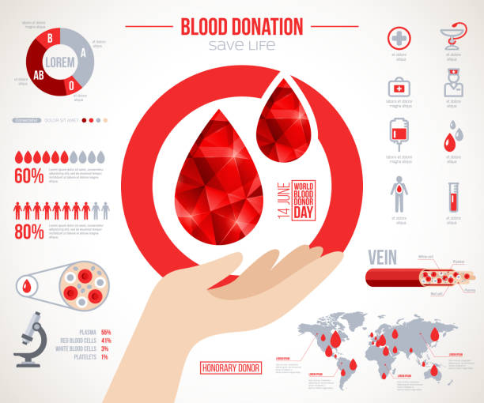

1. Proposed applications

2.1 Abstract –

This project is based on BLOOD BANK & DONOR MANAGEMENT SYSTEM. Blood Bank Management System is a PHP application designed to automate the different operations in Blood Banks. Blood Bank Management System project makes it easy to give information regarding blood type, date of & Donor of blood, available blood group and many more. After the implementation of the project, the blood searching process is expected to be faster, easier, and reliable. Admin will view the donor side and view the available blood requested by the users. Therefore, with the use of online blood bank management system, blood transfusion process is safe and secured. Threats on improper blood donor documentation, or misplaced records will be totally eradicated. Also, processes involving recording about blood donors, blood bag collection, storage, and inventory will be systematized and organized, hence, improving the healthcare management for blood banks.

2.2 Objective –

The objectives of the system are –

This applied research aims to design, develop and implement online blood bank management system.

This web-based application provides:

* To ensure hospital to have good supply or inventories of blood bags.
* To check the availability of blood bags anytime.
* To manage the information of its blood donor.
* Function to check if the person donate blood for the last 3 months.
* To allow good documentation about the donor and its blood & Donor activities.
* Support fast searching to find match blood bags for the right person.

**Key Words:** Php Online Blood Bank Management System, Blood Bank Management, Blood & Donor, Blood Transfusion Safety, Web-Based Applicationetc.

2.2.1 Software requirement -

a. Compiler and code editor -

* Visual studio (vs) **-**

Microsoft Visual Studio is an integrated development environment from Microsoft. It is used to develop computer programs, as well as websites, web apps, web services and mobile apps

b. Programming language used -

* PHP -

PHP ( PHP:Hypertext Preprocessor ) is a widely-used open source general-purpose scripting language that is especially suited for web development

PHP allows web developers to create dynamic content and interact with databases. PHP is known for its simplicity, speed, and flexibility — features that have made it a cornerstone in the web development world.

PHP is an open-source server-side scripting language that many devs use for web development. It is also a general-purpose language that you can use to make lots of projects, including Graphical User Interfaces (GUIs).

2.2.2 Hardware requirements -

A personal computer with internet connection with maximum 1 gigabytes of space and 4 gigabytes of ram with any operating system and a browser.

* 1. Feasibility study on BBDMS -

**1.Financial feasibility:**

Financial feasibility refers to financial support required. It refers to finance incurred during the development of the project.

**2.Behavioural feasibility:**

Refers to reaction of the people towards the project.

**3.Operational feasibility:**

Operational feasibility means is it possible to practically implement the project. While installing this software, the hardware and software requirements should be specified.**Blood bank management system** is an online software system that helps in managing various **blood banks** in a better way.

**4.Technical Feasibility**

The study is carried out to check the technical feasibility, that is, thetechnical requirements of the system. Any system developed must not have a highdemand on the available technical resources.

**5.Economic Feasibility**

To implement the system, we require more than one computer. Since the system will be implemented in existing environment there will be no need to buy the computers. The system is economically feasible to implement.

**6.Operational Feasibility**

Our system will be easy to install and use. Hence our system is operationally feasible.

**7.Cost-Benefit Analysis**

The cost incurred by our system includes only the software cost and cost of the computer needed to run the project The benefits incurred by our system will include.

2.5 About BBDMS -

web based mechanism inter connects all the Blood Banks of the State into a single network. Integrated Blood Bank MIS refers the acquisition, validation, storage and circulation of various live data and information electronically regarding blood & Donor and transfusion service.

**Scope and Boundaries**

Scope of this system can be described as follows:-

1.The project consists of a central repository containing various blood deposits available along with associated details.

2.These details include blood type, storage area and date of storage.

3.The software system is an online blood bank management system that helps in managing various blood bank operations effectively.

4.The project consists of a central repository containing various blood deposits available along with associated details.

5. These details include blood type, storage area and date of storage.

* **User view**

1. **Admin:** It is the administrator account having rights to govern whole software. He can create and delete student and details ,create and change password, he also have rights to add and delete record, various criteria and notification.
2. **User:** users are having only read permission; user type can only see his details, he will not be able to manipulate or change any information, it also has same privileges as that of admi
   1. Gallery –



1. System analysis

3.1 System diagram -

Data Flow Diagrams -

A] Context Level Data Flow Diagram : -

Blood Seekers

Blood Bank Donation Management System

Blood Donars

B] First Level DFD : -

Registration

Donor

Blood Donors

Register

Life Saving Contacts

Registration

Blood

Donationg

Blood Bank Donation

Donor

Services

Receiving

Mobilink Paging Services

Blood Seekers

Search

Search

C] ERD Diagram :-

**Blood**

Donates

**Donor**

Seekers

Registeration

Employed By

Blood bank manages

Blood bank

3.2 Source codes (input)-

* PHP

using System;

using System.Collections.Generic;

using System.Linq;

using System.Threading.Tasks;

using System.Windows.Forms;

namespace CMS

{

internal static class Program

{

/// <summary>

/// The main entry point for the application.

/// </summary>

[STAThread]

static void Main()

{

Application.EnableVisualStyles();

Application.SetCompatibleTextRenderingDefault(false);

Application.Run(new Form1());

}

}

}

1. **Contact.php**
2. <?php
3. session\_start();
4. error\_reporting(0);
5. include('includes/config.php');
6. if(isset($\_POST['send']))
7. {
8. $name=$\_POST['fullname'];
9. $email=$\_POST['email'];
10. $contactno=$\_POST['contactno'];
11. $message=$\_POST['message'];
12. $sql="INSERT INTO tblcontactusquery(name,EmailId,ContactNumber,Message) VALUES(:name,:email,:contactno,:message)";
13. $query = $dbh->prepare($sql);
14. $query->bindParam(':name',$name,PDO::PARAM\_STR);
15. $query->bindParam(':email',$email,PDO::PARAM\_STR);
16. $query->bindParam(':contactno',$contactno,PDO::PARAM\_STR);
17. $query->bindParam(':message',$message,PDO::PARAM\_STR);
18. $query->execute();
19. $lastInsertId = $dbh->lastInsertId();
20. if($lastInsertId)
21. {
22. echo '<script>alert("Query Sent. We will contact you shortly.")</script>';
23. }
24. else
25. {
26. echo "<script>alert('Something went wrong. Please try again.');</script>";
27. }
28. }
29. ?>
30. <!DOCTYPE html>
31. <html lang="zxx">
32. <head>
33. <title>Blood Bank Donar Management System | Contact Us </title>
34. <!-- Meta tag Keywords -->
36. <script>
37. addEventListener("load", function () {
38. setTimeout(hideURLbar, 0);
39. }, false);
40. function hideURLbar() {
41. window.scrollTo(0, 1);
42. }
43. </script>
44. <!--// Meta tag Keywords -->
45. <!-- Custom-Files -->
46. <link rel="stylesheet" href="css/bootstrap.css">
47. <!-- Bootstrap-Core-CSS -->
48. <link rel="stylesheet" href="css/style.css" type="text/css" media="all" />
49. <!-- Style-CSS -->
50. <link rel="stylesheet" href="css/fontawesome-all.css">
51. <!-- Font-Awesome-Icons-CSS -->
52. <!-- //Custom-Files -->
53. <!-- Web-Fonts -->
54. <link href="//fonts.googleapis.com/css?family=Open+Sans:300,300i,400,400i,600,600i,700,700i,800,800i&amp;subset=cyrillic,cyrillic-ext,greek,greek-ext,latin-ext,vietnamese"
55. rel="stylesheet">
56. <link href="//fonts.googleapis.com/css?family=Roboto+Condensed:300,300i,400,400i,700,700i&amp;subset=cyrillic,cyrillic-ext,greek,greek-ext,latin-ext,vietnamese"
57. rel="stylesheet">
58. <!-- //Web-Fonts -->
59. </head>
60. <body>
61. <?php include('includes/header.php');?>
62. <!-- banner 2 -->
63. <div class="inner-banner-w3ls">
64. <div class="container">
65. </div>
66. <!-- //banner 2 -->
67. </div>
68. <!-- page details -->
69. <div class="breadcrumb-agile">
70. <div aria-label="breadcrumb">
71. <ol class="breadcrumb">
72. <li class="breadcrumb-item">
73. <a href="index.php">Home</a>
74. </li>
75. <li class="breadcrumb-item active" aria-current="page">Contact Us</li>
76. </ol>
77. </div>
78. </div>
79. <!-- //page details -->
80. <!-- contact -->
81. <div class="agileits-contact py-5">
82. <div class="py-xl-5 py-lg-3">
83. <div class="w3ls-titles text-center mb-5">
84. <h3 class="title">Contact Us</h3>
85. <span>
86. <i class="fas fa-user-md"></i>
87. </span>
88. <p class="mt-2">Sed do eiusmod tempor incididunt ut labore et dolore magna aliqua.</p>
89. </div>
90. <div class="d-flex">
91. <div class="col-lg-5 w3\_agileits-contact-left">
92. </div>
93. <div class="col-lg-7 contact-right-w3l">
94. <h5 class="title-w3 text-center mb-5">Get In Touch</h5>
95. <form action="#" method="post">
96. <div class="d-flex space-d-flex">
97. <div class="form-group grid-inputs">
98. <input type="text" class="form-control" id="name" name="fullname" placeholder="Please enter your name.">
99. </div>
100. <div class="form-group grid-inputs">
101. <input type="tel" class="form-control" id="phone" name="contactno" placeholder="Please enter your phone number.">
102. </div>
103. </div>
104. <div class="form-group">
105. <input type="email" class="form-control" id="email" name="email" required placeholder="Please enter your email address.">
106. </div>
108. <div class="form-group">
109. <textarea rows="10" cols="100" class="form-control" id="message" name="message" placeholder="Please enter your message" maxlength="999" style="resize:none"></textarea>
110. </div>
111. <div class="form-group">
112. <input type="submit" value="Send Message" name="send">
113. </div>
114. </form>
115. </div>
116. </div>
117. </div>
118. </div>
119. <!-- //contact -->
121. <?php include('includes/footer.php');?>
122. <!-- Js files -->
123. <!-- JavaScript -->
124. <script src="js/jquery-2.2.3.min.js"></script>
125. <!-- Default-JavaScript-File -->
126. <!-- banner slider -->
127. <script src="js/responsiveslides.min.js"></script>
128. <script>
129. $(function () {
130. $("#slider4").responsiveSlides({
131. auto: true,
132. pager: true,
133. nav: true,
134. speed: 1000,
135. namespace: "callbacks",
136. before: function () {
137. $('.events').append("<li>before event fired.</li>");
138. },
139. after: function () {
140. $('.events').append("<li>after event fired.</li>");
141. }
142. });
143. });
144. </script>
145. <!-- //banner slider -->
146. <!-- fixed navigation -->
147. <script src="js/fixed-nav.js"></script>
148. <!-- //fixed navigation -->
149. <!-- smooth scrolling -->
150. <script src="js/SmoothScroll.min.js"></script>
151. <!-- move-top -->
152. <script src="js/move-top.js"></script>
153. <!-- easing -->
154. <script src="js/easing.js"></script>
155. <!-- necessary snippets for few javascript files -->
156. <script src="js/medic.js"></script>
157. <script src="js/bootstrap.js"></script>
158. <!-- Necessary-JavaScript-File-For-Bootstrap -->
159. <!-- //Js files -->
160. </body>
161. </html>

**Contact blood.php**

<?php

session\_start();

error\_reporting(0);

include('includes/config.php');

if(isset($\_POST['send']))

{

$cid=$\_GET['cid'];

$name=$\_POST['fullname'];

$email=$\_POST['email'];

$contactno=$\_POST['contactno'];

$brf=$\_POST['brf'];

$message=$\_POST['message'];

$sql="INSERT INTO tblbloodrequirer(BloodDonarID,name,EmailId,ContactNumber,BloodRequirefor,Message) VALUES(:cid,:name,:email,:contactno,:brf,:message)";

$query = $dbh->prepare($sql);

$query->bindParam(':cid',$cid,PDO::PARAM\_STR);

$query->bindParam(':name',$name,PDO::PARAM\_STR);

$query->bindParam(':email',$email,PDO::PARAM\_STR);

$query->bindParam(':contactno',$contactno,PDO::PARAM\_STR);

$query->bindParam(':brf',$brf,PDO::PARAM\_STR);

$query->bindParam(':message',$message,PDO::PARAM\_STR);

$query->execute();

$lastInsertId = $dbh->lastInsertId();

if($lastInsertId)

{

echo '<script>alert("Request has been sent. We will contact you shortly.")</script>';

}

else

{

echo "<script>alert('Something went wrong. Please try again.');</script>";

}

}

?>

<!DOCTYPE html>

<html lang="zxx">

<head>

<title>Blood Bank Donar Management System | Blood Requerer </title>

<!-- Meta tag Keywords -->

<script>

addEventListener("load", function () {

setTimeout(hideURLbar, 0);

}, false);

function hideURLbar() {

window.scrollTo(0, 1);

}

</script>

<!--// Meta tag Keywords -->

<!-- Custom-Files -->

<link rel="stylesheet" href="css/bootstrap.css">

<!-- Bootstrap-Core-CSS -->

<link rel="stylesheet" href="css/style.css" type="text/css" media="all" />

<!-- Style-CSS -->

<link rel="stylesheet" href="css/fontawesome-all.css">

<!-- Font-Awesome-Icons-CSS -->

<!-- //Custom-Files -->

<!-- Web-Fonts -->

<link href="//fonts.googleapis.com/css?family=Open+Sans:300,300i,400,400i,600,600i,700,700i,800,800i&amp;subset=cyrillic,cyrillic-ext,greek,greek-ext,latin-ext,vietnamese"

rel="stylesheet">

<link href="//fonts.googleapis.com/css?family=Roboto+Condensed:300,300i,400,400i,700,700i&amp;subset=cyrillic,cyrillic-ext,greek,greek-ext,latin-ext,vietnamese"

rel="stylesheet">

<!-- //Web-Fonts -->

</head>

<body>

<?php include('includes/header.php');?>

<!-- banner 2 -->

<div class="inner-banner-w3ls">

<div class="container">

</div>

<!-- //banner 2 -->

</div>

<!-- page details -->

<div class="breadcrumb-agile">

<div aria-label="breadcrumb">

<ol class="breadcrumb">

<li class="breadcrumb-item">

<a href="index.php">Home</a>

</li>

<li class="breadcrumb-item active" aria-current="page">Blood Needed Person</li>

</ol>

</div>

</div>

<!-- //page details -->

<!-- contact -->

<div class="agileits-contact py-5">

<div class="py-xl-5 py-lg-3">

<div class="w3ls-titles text-center mb-5">

<h3 class="title">Contact For Blood</h3>

<span>

<i class="fas fa-user-md"></i>

</span>

</div>

<div class="d-flex">

<div class="col-lg-5 w3\_agileits-contact-left">

</div>

<div class="col-lg-7 contact-right-w3l">

<h5 class="title-w3 text-center mb-5"><h5 class="title-w3 text-center mb-5">Fill following form for blood</h5></h5>

<form action="#" method="post">

<div class="d-flex space-d-flex">

<div class="form-group grid-inputs">

<label for="recipient-name" class="col-form-label">Your Name</label>

<input type="text" class="form-control" id="name" name="fullname" placeholder="Please enter your name.">

</div>

<div class="form-group grid-inputs">

<label for="recipient-name" class="col-form-label">Phone Number</label>

<input type="tel" class="form-control" id="phone" name="contactno" placeholder="Please enter your phone number.">

</div>

</div>

<div class="d-flex space-d-flex">

<div class="form-group grid-inputs">

<label for="recipient-name" class="col-form-label">Email Address</label>

<input type="email" class="form-control" id="email" name="email" required placeholder="Please enter your email address.">

</div>

<div class="form-group grid-inputs">

<label for="recipient-name" class="col-form-label">Blood Require For</label>

<select class="form-control" id="phone" name="brf">

<option value="">Blood Require For</option>

<option value="Father">Father</option>

<option value="Mother">Mother</option>

<option value="Brother">Brother</option>

<option value="Sister">Sister</option>

<option value="Others">Others</option>

</select>

</div>

</div>

<div class="form-group">

<label for="recipient-name" class="col-form-label">Message</label>

<textarea rows="10" cols="100" class="form-control" id="message" name="message" placeholder="Please enter your message" maxlength="999" style="resize:none"></textarea>

</div>

<div class="form-group">

<input type="submit" value="Send Message" name="send">

</div>

</form>

</div>

</div>

</div>

</div>

<!-- //contact -->

<?php include('includes/footer.php');?>

<!-- Js files -->

<!-- JavaScript -->

<script src="js/jquery-2.2.3.min.js"></script>

<!-- Default-JavaScript-File -->

<!-- banner slider -->

<script src="js/responsiveslides.min.js"></script>

<script>

$(function () {

$("#slider4").responsiveSlides({

auto: true,

pager: true,

nav: true,

speed: 1000,

namespace: "callbacks",

before: function () {

$('.events').append("<li>before event fired.</li>");

},

after: function () {

$('.events').append("<li>after event fired.</li>");

}

});

});

</script>

<!-- //banner slider -->

<!-- fixed navigation -->

<script src="js/fixed-nav.js"></script>

<!-- //fixed navigation -->

<!-- smooth scrolling -->

<script src="js/SmoothScroll.min.js"></script>

<!-- move-top -->

<script src="js/move-top.js"></script>

<!-- easing -->

<script src="js/easing.js"></script>

<!-- necessary snippets for few javascript files -->

<script src="js/medic.js"></script>

<script src="js/bootstrap.js"></script>

<!-- Necessary-JavaScript-File-For-Bootstrap -->

<!-- //Js files -->

</body>

</html>

**Search-Donor.php**

<?php

//error\_reporting(0);

include('includes/config.php');

?>

<!DOCTYPE html>

<html lang="zxx">

<head>

<title>Blood Bank Donar Management System | Search Blood Donor </title>

<!-- Meta tag Keywords -->

<script>

addEventListener("load", function () {

setTimeout(hideURLbar, 0);

}, false);

function hideURLbar() {

window.scrollTo(0, 1);

}

</script>

<!--// Meta tag Keywords -->

<!-- Custom-Files -->

<link rel="stylesheet" href="css/bootstrap.css">

<!-- Bootstrap-Core-CSS -->

<link rel="stylesheet" href="css/style.css" type="text/css" media="all" />

<!-- Style-CSS -->

<link rel="stylesheet" href="css/fontawesome-all.css">

<!-- Font-Awesome-Icons-CSS -->

<!-- //Custom-Files -->

<!-- Web-Fonts -->

<link href="//fonts.googleapis.com/css?family=Open+Sans:300,300i,400,400i,600,600i,700,700i,800,800i&amp;subset=cyrillic,cyrillic-ext,greek,greek-ext,latin-ext,vietnamese"

rel="stylesheet">

<link href="//fonts.googleapis.com/css?family=Roboto+Condensed:300,300i,400,400i,700,700i&amp;subset=cyrillic,cyrillic-ext,greek,greek-ext,latin-ext,vietnamese"

rel="stylesheet">

<!-- //Web-Fonts -->

</head>

<body>

<?php include('includes/header.php');?>

<!-- banner 2 -->

<div class="inner-banner-w3ls">

<div class="container">

</div>

<!-- //banner 2 -->

</div>

<!-- page details -->

<div class="breadcrumb-agile">

<div aria-label="breadcrumb">

<ol class="breadcrumb">

<li class="breadcrumb-item">

<a href="index.php">Home</a>

</li>

<li class="breadcrumb-item active" aria-current="page">Blood Donar List</li>

</ol>

</div>

</div>

<!-- //page details -->

<!-- contact -->

<div class="agileits-contact py-5">

<div class="py-xl-5 py-lg-3">

<form name="donar" method="post" style="padding-left: 30px;">

<div class="row">

<div class="col-lg-4 mb-4">

<div class="font-italic">Blood Group<span style="color:red">\*</span> </div>

<div><select name="bloodgroup" class="form-control" required>

<?php $sql = "SELECT \* from tblbloodgroup ";

$query = $dbh -> prepare($sql);

$query->execute();

$results=$query->fetchAll(PDO::FETCH\_OBJ);

$cnt=1;

if($query->rowCount() > 0)

{

foreach($results as $result)

{ ?>

<option value="<?php echo htmlentities($result->BloodGroup);?>"><?php echo htmlentities($result->BloodGroup);?></option>

<?php }} ?>

</select>

</div>

</div>

<div class="col-lg-4 mb-4">

<div class="font-italic">Location </div>

<div><textarea class="form-control" name="location"></textarea></div>

</div>

</div>

<div class="row">

<div class="col-lg-4 mb-4">

<div><input type="submit" name="sub" class="btn btn-primary" value="submit" style="cursor:pointer"></div>

</div>

</div>

<!-- /.row -->

</form>

<div class="agileits-contact py-5">

<div class="py-xl-5 py-lg-3">

<?php

if(isset($\_POST['sub']))

{

$status=1;

$bloodgroup=$\_POST['bloodgroup'];

$location=$\_POST['location'];

$sql = "SELECT \* from tblblooddonars where (status=:status and BloodGroup=:bloodgroup) || (Address=:location)";

$query = $dbh -> prepare($sql);

$query->bindParam(':status',$status,PDO::PARAM\_STR);

$query->bindParam(':bloodgroup',$bloodgroup,PDO::PARAM\_STR);

$query->bindParam(':location',$location,PDO::PARAM\_STR);

$query->execute();

$results=$query->fetchAll(PDO::FETCH\_OBJ);

$cnt=1;

if($query->rowCount() > 0)

{ ?>

<div class="w3ls-titles text-center mb-5">

<h3 class="title">Search Blood Donor</h3>

<span>

<i class="fas fa-user-md"></i>

</span>

</div>

<div class="d-flex">

<div class="row package-grids mt-5" style="padding-left: 50px;">

<?php foreach($results as $result)

{ ?>

<div class="col-md-6 pricing">

<div class="price-top">

<a href="single.html">

<img src="images/blood-donor.jpg" alt="Blood Donor" style="border:1px #000 solid" class="img-fluid" />

</a>

<h3><?php echo htmlentities($result->FullName);?>

</h3>

</div>

<div class="price-bottom p-4">

<table class="table table-bordered">

<tbody>

<tr>

<th>Gender</th>

<td><?php echo htmlentities($result->Gender);?></td>

</tr>

<tr>

<td>Blood Group</td>

<td><?php echo htmlentities($result->BloodGroup);?></td>

</tr>

<tr>

<td>Mobile No.</td>

<td><?php echo htmlentities($result->MobileNumber);?></td>

</tr>

<tr>

<td>Email ID</td>

<td><?php echo htmlentities($result->EmailId);?></td>

</tr>

<tr>

<td>Age</td>

<td><?php echo htmlentities($result->Age);?></td>

</tr>

<tr>

<td>Address</td>

<td><?php echo htmlentities($result->Address);?></td>

</tr>

<tr>

<td>Message</td>

<td><?php echo htmlentities($result->Message);?></td>

</tr>

</tbody>

</table>

<a class="btn btn-primary" style="color:#fff" href="contact-blood.php?cid=<?php echo $result->id;?>">Request</a>

</div>

</div> <?php }}

else

{

echo htmlentities("No Record Found");

}

} ?>

</div>

</div>

</div>

</div>

<!-- //contact -->

<?php include('includes/footer.php');?>

<!-- Js files -->

<!-- JavaScript -->

<script src="js/jquery-2.2.3.min.js"></script>

<!-- Default-JavaScript-File -->

<!-- banner slider -->

<script src="js/responsiveslides.min.js"></script>

<script>

$(function () {

$("#slider4").responsiveSlides({

auto: true,

pager: true,

nav: true,

speed: 1000,

namespace: "callbacks",

before: function () {

$('.events').append("<li>before event fired.</li>");

},

after: function () {

$('.events').append("<li>after event fired.</li>");

}

});

});

</script>

<!-- //banner slider -->

<!-- fixed navigation -->

<script src="js/fixed-nav.js"></script>

<!-- //fixed navigation -->

<!-- smooth scrolling -->

<script src="js/SmoothScroll.min.js"></script>

<!-- move-top -->

<script src="js/move-top.js"></script>

<!-- easing -->

<script src="js/easing.js"></script>

<!-- necessary snippets for few javascript files -->

<script src="js/medic.js"></script>

<script src="js/bootstrap.js"></script>

<!-- Necessary-JavaScript-File-For-Bootstrap -->

<!-- //Js files -->

</body>

</html>

**Donar-list.php**

<?php

error\_reporting(0);

include('includes/config.php');

?>

<!DOCTYPE html>

<html lang="zxx">

<head>

<title>Blood Bank Donar Management System | Blood Donor List </title>

<!-- Meta tag Keywords -->

<script>

addEventListener("load", function () {

setTimeout(hideURLbar, 0);

}, false);

function hideURLbar() {

window.scrollTo(0, 1);

}

</script>

<!--// Meta tag Keywords -->

<!-- Custom-Files -->

<link rel="stylesheet" href="css/bootstrap.css">

<!-- Bootstrap-Core-CSS -->

<link rel="stylesheet" href="css/style.css" type="text/css" media="all" />

<!-- Style-CSS -->

<link rel="stylesheet" href="css/fontawesome-all.css">

<!-- Font-Awesome-Icons-CSS -->

<!-- //Custom-Files -->

<!-- Web-Fonts -->

<link href="//fonts.googleapis.com/css?family=Open+Sans:300,300i,400,400i,600,600i,700,700i,800,800i&amp;subset=cyrillic,cyrillic-ext,greek,greek-ext,latin-ext,vietnamese"

rel="stylesheet">

<link href="//fonts.googleapis.com/css?family=Roboto+Condensed:300,300i,400,400i,700,700i&amp;subset=cyrillic,cyrillic-ext,greek,greek-ext,latin-ext,vietnamese"

rel="stylesheet">

<!-- //Web-Fonts -->

</head>

<body>

<?php include('includes/header.php');?>

<!-- banner 2 -->

<div class="inner-banner-w3ls">

<div class="container">

</div>

<!-- //banner 2 -->

</div>

<!-- page details -->

<div class="breadcrumb-agile">

<div aria-label="breadcrumb">

<ol class="breadcrumb">

<li class="breadcrumb-item">

<a href="index.php">Home</a>

</li>

<li class="breadcrumb-item active" aria-current="page">Blood Donar List</li>

</ol>

</div>

</div>

<!-- //page details -->

<!-- contact -->

<div class="agileits-contact py-5">

<div class="py-xl-5 py-lg-3">

<div class="w3ls-titles text-center mb-5">

<h3 class="title">Blood Donor List</h3>

<span>

<i class="fas fa-user-md"></i>

</span>

<p class="mt-2">Sed do eiusmod tempor incididunt ut labore et dolore magna aliqua.</p>

</div>

<div class="d-flex">

<div class="row package-grids mt-5" style="padding-left: 50px;">

<?php

$status=1;

$sql = "SELECT \* from tblblooddonars where status=:status";

$query = $dbh -> prepare($sql);

$query->bindParam(':status',$status,PDO::PARAM\_STR);

$query->execute();

$results=$query->fetchAll(PDO::FETCH\_OBJ);

$cnt=1;

if($query->rowCount() > 0)

{

foreach($results as $result)

{ ?>

<div class="col-md-4 pricing">

<div class="price-top">

<img src="images/blood-donor.jpg" alt="Blood Donot" style="border:1px #000 solid" class="img-fluid" />

<h3><?php echo htmlentities($result->FullName);?>

</h3>

</div>

<div class="price-bottom p-4">

<table class="table table-bordered">

<tbody>

<tr>

<th>Gender</th>

<td><?php echo htmlentities($result->Gender);?></td>

</tr>

<tr>

<td>Blood Group</td>

<td><?php echo htmlentities($result->BloodGroup);?></td>

</tr>

<tr>

<td>Mobile No.</td>

<td><?php echo htmlentities($result->MobileNumber);?></td>

</tr>

<tr>

<td>Email ID</td>

<td><?php echo htmlentities($result->EmailId);?></td>

</tr>

<tr>

<td>Age</td>

<td><?php echo htmlentities($result->Age);?></td>

</tr>

<tr>

<td>Address</td>

<td><?php echo htmlentities($result->Address);?></td>

</tr>

<tr>

<td>Message</td>

<td><?php echo htmlentities($result->Message);?></td>

</tr>

</tbody>

</table>

<a class="btn btn-primary" style="color:#fff" href="contact-blood.php?cid=<?php echo $result->id;?>">Request</a>

</div>

</div><br>

<?php }} ?>

</div>

</div>

</div>

</div>

<!-- //contact -->

<?php include('includes/footer.php');?>

<!-- Js files -->

<!-- JavaScript -->

<script src="js/jquery-2.2.3.min.js"></script>

<!-- Default-JavaScript-File -->

<!-- banner slider -->

<script src="js/responsiveslides.min.js"></script>

<script>

$(function () {

$("#slider4").responsiveSlides({

auto: true,

pager: true,

nav: true,

speed: 1000,

namespace: "callbacks",

before: function () {

$('.events').append("<li>before event fired.</li>");

},

after: function () {

$('.events').append("<li>after event fired.</li>");

}

});

});

</script>

<!-- //banner slider -->

<!-- fixed navigation -->

<script src="js/fixed-nav.js"></script>

<!-- //fixed navigation -->

<!-- smooth scrolling -->

<script src="js/SmoothScroll.min.js"></script>

<!-- move-top -->

<script src="js/move-top.js"></script>

<!-- easing -->

<script src="js/easing.js"></script>

<!-- necessary snippets for few javascript files -->

<script src="js/medic.js"></script>

<script src="js/bootstrap.js"></script>

<!-- Necessary-JavaScript-File-For-Bootstrap -->

<!-- //Js files -->

</body>

</html>

**Request-Received.php**

1. <?php
2. session\_start();
3. error\_reporting(0);
4. include('includes/config.php');
5. if (strlen($\_SESSION['bbdmsdid']==0)) {
6. header('location:logout.php');
7. } else{
8. ?>
9. <!DOCTYPE html>
10. <html lang="zxx">
11. <head>
12. <title>Blood Bank Donar Management System !! Request Received</title>
14. <script>
15. addEventListener("load", function () {
16. setTimeout(hideURLbar, 0);
17. }, false);
18. function hideURLbar() {
19. window.scrollTo(0, 1);
20. }
21. </script>
22. <script type="text/javascript">
23. function checkpass()
24. {
25. if(document.changepassword.newpassword.value!=document.changepassword.confirmpassword.value)
26. {
27. alert('New Password and Confirm Password field does not match');
28. document.changepassword.confirmpassword.focus();
29. return false;
30. }
31. return true;
32. }
33. </script>
34. <!-- Custom-Files -->
35. <link rel="stylesheet" href="css/bootstrap.css">
36. <!-- Bootstrap-Core-CSS -->
37. <link rel="stylesheet" href="css/style.css" type="text/css" media="all" />
38. <!-- Style-CSS -->
39. <link rel="stylesheet" href="css/fontawesome-all.css">
40. <!-- Font-Awesome-Icons-CSS -->
41. <!-- //Custom-Files -->
42. <!-- Web-Fonts -->
43. <link href="//fonts.googleapis.com/css?family=Open+Sans:300,300i,400,400i,600,600i,700,700i,800,800i&amp;subset=cyrillic,cyrillic-ext,greek,greek-ext,latin-ext,vietnamese"
44. rel="stylesheet">
45. <link href="//fonts.googleapis.com/css?family=Roboto+Condensed:300,300i,400,400i,700,700i&amp;subset=cyrillic,cyrillic-ext,greek,greek-ext,latin-ext,vietnamese"
46. rel="stylesheet">
47. <!-- //Web-Fonts -->
48. </head>
49. <body>
50. <?php include('includes/header.php');?>
51. <!-- banner 2 -->
52. <div class="inner-banner-w3ls">
53. <div class="container">
54. </div>
55. <!-- //banner 2 -->
56. </div>
57. <!-- page details -->
58. <div class="breadcrumb-agile">
59. <div aria-label="breadcrumb">
60. <ol class="breadcrumb">
61. <li class="breadcrumb-item">
62. <a href="index.php">Home</a>
63. </li>
64. <li class="breadcrumb-item active" aria-current="page">Request Received</li>
65. </ol>
66. </div>
67. </div>
68. <!-- //page details -->
69. <!-- contact -->
70. <div class="appointment py-5">
71. <div class="py-xl-5 py-lg-3">
72. <div class="w3ls-titles text-center mb-5">
73. <h3 class="title">Request Received</h3>
74. <span>
75. <i class="fas fa-user-md"></i>
76. </span>
77. </div>
78. <div class="d-flex">
80. <div class="contact-right-w3l appoint-form" style="width:100% !important;">
81. <h5 class="title-w3 text-center mb-5">Below is the detail of Blood Requirer.</h5>
82. <table border="1" class="table table-bordered">
83. <thead>
84. <tr>
85. <th>S.No</th>
87. <th>Name</th>
88. <th>Mobile Number</th>
89. <th>Email</th>
90. <th>Blood Require For</th>
91. <th>Message</th>
92. <th>Apply Date</th>
93. </tr>
94. </thead>
96. <tbody>
98. <tr><?php
99. $uid=$\_SESSION['bbdmsdid'];
100. $sql="SELECT tblbloodrequirer.BloodDonarID,tblbloodrequirer.name,tblbloodrequirer.EmailId,tblbloodrequirer.ContactNumber,tblbloodrequirer.BloodRequirefor,tblbloodrequirer.Message,tblbloodrequirer.ApplyDate,tblblooddonars.id as donid from tblbloodrequirer join tblblooddonars on tblblooddonars.id=tblbloodrequirer.BloodDonarID where tblbloodrequirer.BloodDonarID=:uid";
101. $query = $dbh -> prepare($sql);
102. $query->bindParam(':uid',$uid,PDO::PARAM\_STR);
103. $query->execute();
104. $results=$query->fetchAll(PDO::FETCH\_OBJ);
105. $cnt=1;
106. if($query->rowCount() > 0)
107. {
108. foreach($results as $row)
109. { ?>
110. <td><?php echo htmlentities($cnt);?></td>
111. <td><?php echo htmlentities($row->name);?></td>
112. <td><?php echo htmlentities($row->ContactNumber);?></td>
113. <td><?php echo htmlentities($row->EmailId);?></td>
114. <td><?php echo htmlentities($row->BloodRequirefor);?></td>

117. <td><?php echo htmlentities($row->Message);?>
118. </td>
120. <td>
121. <?php echo htmlentities($row->ApplyDate);?>
122. </td>
123. </tr>
124. <?php $cnt=$cnt+1;}} else {?>
125. <tr>
126. <th colspan="8" style="color:red;"> No Record found</th>
127. </tr>
128. <?php } ?>
129. </tbody>
130. </table>
131. </div>
132. <div class="clerafix"></div>
133. </div>
134. </div>
135. </div>
136. <!-- //contact -->
137. <?php include('includes/footer.php');?>
138. <!-- Js files -->
139. <!-- JavaScript -->
140. <script src="js/jquery-2.2.3.min.js"></script>
141. <!-- Default-JavaScript-File -->
142. <!--start-date-piker-->
143. <link rel="stylesheet" href="css/jquery-ui.css" />
144. <script src="js/jquery-ui.js"></script>
145. <script>
146. $(function () {
147. $("#datepicker,#datepicker1").datepicker();
148. });
149. </script>
150. <!-- //End-date-piker -->
151. <!-- fixed navigation -->
152. <script src="js/fixed-nav.js"></script>
153. <!-- //fixed navigation -->
154. <!-- smooth scrolling -->
155. <script src="js/SmoothScroll.min.js"></script>
156. <!-- move-top -->
157. <script src="js/move-top.js"></script>
158. <!-- easing -->
159. <script src="js/easing.js"></script>
160. <!-- necessary snippets for few javascript files -->
161. <script src="js/medic.js"></script>
162. <script src="js/bootstrap.js"></script>
163. <!-- Necessary-JavaScript-File-For-Bootstrap -->
164. <!-- //Js files -->
165. </body>

</html><?php } ?>

**UserForm7.cs**

using System;

using System.Collections.Generic;

using System.ComponentModel;

using System.Data;

using System.Drawing;

using System.Linq;

using System.Text;

using System.Threading.Tasks;

using System.Windows.Forms;

using System.Data.SqlClient;

namespace CMS

{

public partial class UserForm7 : Form

{

public UserForm7()

{

InitializeComponent();

}

SqlConnection Con = new SqlConnection(@"Data Source=(LocalDB)\MSSQLLocalDB;AttachDbFilename=C:\Users\genis\Documents\Collegedb.mdf;Integrated Security=True;Connect Timeout=30");

private void label2\_Click(object sender, EventArgs e)

{

Application.Exit();

}

private void UserForm7\_Load(object sender, EventArgs e)

{

populate();

}

private void populate()

{

Con.Open();

string query = "select \* from UserTbl";

SqlDataAdapter sda = new SqlDataAdapter(query, Con);

SqlCommandBuilder builder = new SqlCommandBuilder(sda);

var ds = new DataSet();

sda.Fill(ds);

UserDGV.DataSource = ds.Tables[0];

Con.Close();

}

private void button7\_Click(object sender, EventArgs e)

{

try

{

if(UidTb.Text =="" || UnameTb.Text ==""|| UpassTb.Text =="")

{

MessageBox.Show("Missing Information");

}

else

{

Con.Open();

SqlCommand cmd = new SqlCommand("insert into UserTbl values(" + UidTb.Text + ",'" + UnameTb.Text + "','" + UpassTb.Text + "')", Con);

cmd.ExecuteNonQuery();

MessageBox.Show("User successfully added");

Con.Close();

populate();

}

}catch

{

MessageBox.Show("Something went wrong");

}

}

private void UserDGV\_CellContentClick(object sender, DataGridViewCellEventArgs e)

{

UidTb.Text = UserDGV.SelectedRows[0].Cells[0].Value.ToString();

UnameTb.Text = UserDGV.SelectedRows[0].Cells[1].Value.ToString();

UpassTb.Text = UserDGV.SelectedRows[0].Cells[2].Value.ToString();

}

private void button2\_Click(object sender, EventArgs e)

{

try

{

if(UidTb.Text == "")

{

MessageBox.Show("Enter the user id");

}

else

{

Con.Open();

string query = "delete from UserTbl where UserId=" + UidTb.Text + ";";

SqlCommand cmd = new SqlCommand(query, Con);

cmd.ExecuteNonQuery();

MessageBox.Show("User deleted successfully");

Con.Close();

populate();

}

}catch

{

MessageBox.Show("User not deleted");

}

}

private void button1\_Click(object sender, EventArgs e)

{

try

{

if (UidTb.Text == "" || UnameTb.Text == "" || UpassTb.Text == "")

{

MessageBox.Show("Missing data");

}

else

{

Con.Open();

string query = "update UserTbl set UserName='" + UnameTb.Text + "',password='" + UpassTb.Text + "' where UserId=" + UidTb.Text + ";";

SqlCommand cmd = new SqlCommand(query, Con);

cmd.ExecuteNonQuery();

MessageBox.Show("User updated successfully");

Con.Close();

populate();

}

}catch

{

MessageBox.Show("User not deleted");

}

}

private void button3\_Click(object sender, EventArgs e)

{

Homepage3 home = new Homepage3();

home.Show();

this.Hide();

}

}

}

1. **Department8.cs**

using System;

using System.Collections.Generic;

using System.ComponentModel;

using System.Data;

using System.Drawing;

using System.Linq;

using System.Text;

using System.Threading.Tasks;

using System.Windows.Forms;

using System.Data.SqlClient;

namespace CMS

{

public partial class Department8 : Form

{

public Department8()

{

InitializeComponent();

}

SqlConnection Con = new SqlConnection(@"Data Source=(LocalDB)\MSSQLLocalDB;AttachDbFilename=C:\Users\genis\Documents\Collegedb.mdf;Integrated Security=True;Connect Timeout=30");

private void populate()

{

Con.Open();

string query = "select \* from DepartmentTbl";

SqlDataAdapter sda = new SqlDataAdapter(query, Con);

SqlCommandBuilder builder = new SqlCommandBuilder(sda);

var ds = new DataSet();

sda.Fill(ds);

DepDGV.DataSource = ds.Tables[0];

Con.Close();

}

private void label2\_Click(object sender, EventArgs e)

{

Application.Exit();

}

private void button7\_Click(object sender, EventArgs e)

{

try

{

if (DepNameTb.Text == "" || DepDescTb.Text == "" || DepDurationTb.Text == "")

{

MessageBox.Show("Missing Information");

}

else

{

Con.Open();

SqlCommand cmd = new SqlCommand("insert into DepartmentTbl values('" + DepNameTb.Text + "','" + DepDescTb.Text + "','" + DepDurationTb.Text + "')", Con);

cmd.ExecuteNonQuery();

MessageBox.Show("Department successfully added");

Con.Close();

populate();

}

}

catch

{

MessageBox.Show("Something went wrong");

}

}

private void textBox1\_TextChanged(object sender, EventArgs e)

{

}

private void Department8\_Load(object sender, EventArgs e)

{

populate();

}

private void button2\_Click(object sender, EventArgs e)

{

try

{

if (DepNameTb.Text == "")

{

MessageBox.Show("Enter the department name");

}

else

{

Con.Open();

string query = "delete from DepartmentTbl where DepName='" + DepNameTb.Text + "';";

SqlCommand cmd = new SqlCommand(query, Con);

cmd.ExecuteNonQuery();

MessageBox.Show("Department deleted successfully");

Con.Close();

populate();

}

}

catch

{

MessageBox.Show("Department not deleted");

}

}

private void DepDGV\_CellContentClick(object sender, DataGridViewCellEventArgs e)

{

DepNameTb.Text = DepDGV.SelectedRows[0].Cells[0].Value.ToString();

DepDescTb.Text = DepDGV.SelectedRows[0].Cells[1].Value.ToString();

DepDurationTb.Text = DepDGV.SelectedRows[0].Cells[2].Value.ToString();

}

private void button1\_Click(object sender, EventArgs e)

{

try

{

if (DepNameTb.Text == "" || DepDescTb.Text == "" || DepDurationTb.Text == "")

{

MessageBox.Show("Missing data");

}

else

{

Con.Open();

string query = "update DepartmentTbl set DepDesc='" + DepDescTb.Text + "',DepDuration=" + DepDurationTb.Text + " where DepName='" + DepNameTb.Text + "';";

SqlCommand cmd = new SqlCommand(query, Con);

cmd.ExecuteNonQuery();

MessageBox.Show("Department updated successfully");

Con.Close();

populate();

}

}

catch

{

MessageBox.Show("Department not updated");

}

}

private void button3\_Click(object sender, EventArgs e)

{

Homepage3 home = new Homepage3();

home.Show();

this.Hide();

}

}

}

1. **Dashboard9.cs**

using System;

using System.Collections.Generic;

using System.ComponentModel;

using System.Data;

using System.Drawing;

using System.Linq;

using System.Text;

using System.Threading.Tasks;

using System.Windows.Forms;

using System.Data.SqlClient;

namespace CMS

{

public partial class Dashboard9 : Form

{

public Dashboard9()

{

InitializeComponent();

}

SqlConnection Con = new SqlConnection(@"Data Source=(LocalDB)\MSSQLLocalDB;AttachDbFilename=C:\Users\genis\Documents\Collegedb.mdf;Integrated Security=True;Connect Timeout=30");

private void label2\_Click(object sender, EventArgs e)

{

Application.Exit();

}

private void Dashboard9\_Load(object sender, EventArgs e)

{

Con.Open();

SqlDataAdapter sda1 = new SqlDataAdapter("select count(\*) from StudentTbl", Con);

DataTable dt1 = new DataTable();

sda1.Fill(dt1);

Stdlbl.Text = dt1.Rows[0][0].ToString();

SqlDataAdapter sda2 = new SqlDataAdapter("select count(\*) from FeesTbl", Con);

DataTable dt2 = new DataTable();

sda2.Fill(dt2);

Feeslbl.Text = "Rs:"+Convert.ToInt32(dt2.Rows[0][0].ToString())\*25000;

SqlDataAdapter sda3 = new SqlDataAdapter("select count(\*) from TeacherTbl", Con);

DataTable dt3 = new DataTable();

sda3.Fill(dt3);

Teacherlbl.Text = dt3.Rows[0][0].ToString();

SqlDataAdapter sda4 = new SqlDataAdapter("select count(\*) from DepartmentTbl", Con);

DataTable dt4 = new DataTable();

sda4.Fill(dt4);

Deplbl.Text = dt4.Rows[0][0].ToString();

Con.Close();

}

private void button3\_Click(object sender, EventArgs e)

{

Homepage3 home = new Homepage3();

home.Show();

this.Hide();

}

}

}

1. **About10.cs**

**<?php**

**error\_reporting(0);**

**include('includes/config.php');**

**?>**

**<!DOCTYPE html>**

**<html lang="zxx">**

**<head>**

**<title>Blood Bank Donar Management System | About Us </title>**

**<!-- Meta tag Keywords -->**

**<script>**

**addEventListener("load", function () {**

**setTimeout(hideURLbar, 0);**

**}, false);**

**function hideURLbar() {**

**window.scrollTo(0, 1);**

**}**

**</script>**

**<!--// Meta tag Keywords -->**

**<!-- Custom-Files -->**

**<link rel="stylesheet" href="css/bootstrap.css">**

**<!-- Bootstrap-Core-CSS -->**

**<link rel="stylesheet" href="css/style.css" type="text/css" media="all" />**

**<!-- Style-CSS -->**

**<link rel="stylesheet" href="css/fontawesome-all.css">**

**<!-- Font-Awesome-Icons-CSS -->**

**<!-- //Custom-Files -->**

**<!-- Web-Fonts -->**

**<link href="//fonts.googleapis.com/css?family=Open+Sans:300,300i,400,400i,600,600i,700,700i,800,800i&amp;subset=cyrillic,cyrillic-ext,greek,greek-ext,latin-ext,vietnamese"**

**rel="stylesheet">**

**<link href="//fonts.googleapis.com/css?family=Roboto+Condensed:300,300i,400,400i,700,700i&amp;subset=cyrillic,cyrillic-ext,greek,greek-ext,latin-ext,vietnamese"**

**rel="stylesheet">**

**<!-- //Web-Fonts -->**

**</head>**

**<body>**

**<?php include('includes/header.php');?>**

**<!-- banner 2 -->**

**<div class="inner-banner-w3ls">**

**<div class="container">**

**</div>**

**<!-- //banner 2 -->**

**</div>**

**<!-- page details -->**

**<div class="breadcrumb-agile">**

**<div aria-label="breadcrumb">**

**<ol class="breadcrumb">**

**<li class="breadcrumb-item">**

**<a href="index.php">Home</a>**

**</li>**

**<li class="breadcrumb-item active" aria-current="page">About Us</li>**

**</ol>**

**</div>**

**</div>**

**<!-- //page details -->**

**<!-- about -->**

**<section class="about py-5">**

**<div class="container py-xl-5 py-lg-3">**

**<?php**

**$pagetype="aboutus";**

**$sql = "SELECT type,detail,PageName from tblpages where type=:pagetype";**

**$query = $dbh -> prepare($sql);**

**$query->bindParam(':pagetype',$pagetype,PDO::PARAM\_STR);**

**$query->execute();**

**$results=$query->fetchAll(PDO::FETCH\_OBJ);**

**$cnt=1;**

**if($query->rowCount() > 0)**

**{**

**foreach($results as $result)**

**{ ?>**

**<div class="w3ls-titles text-center mb-md-5 mb-4">**

**<h3 class="title"><?php echo htmlentities($result->PageName); ?></h3>**

**<span>**

**<i class="fas fa-user-md"></i>**

**</span>**

**</div>**

**<p class="aboutpara text-center mx-auto"><?php echo $result->detail; ?>.</p>**

**<?php } } ?>**

**</div>**

**</section>**

**<!-- //about -->**

**<?php include('includes/footer.php');?>**

**<!-- Js files -->**

**<!-- JavaScript -->**

**<script src="js/jquery-2.2.3.min.js"></script>**

**<!-- Default-JavaScript-File -->**

**<!-- banner slider -->**

**<script src="js/responsiveslides.min.js"></script>**

**<script>**

**$(function () {**

**$("#slider4").responsiveSlides({**

**auto: true,**

**pager: true,**

**nav: true,**

**speed: 1000,**

**namespace: "callbacks",**

**before: function () {**

**$('.events').append("<li>before event fired.</li>");**

**},**

**after: function () {**

**$('.events').append("<li>after event fired.</li>");**

**}**

**});**

**});**

**</script>**

**<!-- //banner slider -->**

**<!-- fixed navigation -->**

**<script src="js/fixed-nav.js"></script>**

**<!-- //fixed navigation -->**

**<!-- smooth scrolling -->**

**<script src="js/SmoothScroll.min.js"></script>**

**<!-- move-top -->**

**<script src="js/move-top.js"></script>**

**<!-- easing -->**

**<script src="js/easing.js"></script>**

**<!-- necessary snippets for few javascript files -->**

**<script src="js/medic.js"></script>**

**<script src="js/bootstrap.js"></script>**

**<!-- Necessary-JavaScript-File-For-Bootstrap -->**

**<!-- //Js files -->**

**</body>**

**</html>sss**

1. **Devloper11.cs**

using System;

using System.Collections.Generic;

using System.ComponentModel;

using System.Data;

using System.Drawing;

using System.Linq;

using System.Text;

using System.Threading.Tasks;

using System.Windows.Forms;

namespace CMS

{

public partial class Devloper11 : Form

{

public Devloper11()

{

InitializeComponent();

}

private void label2\_Click(object sender, EventArgs e)

{

Application.Exit();

}

private void button3\_Click(object sender, EventArgs e)

{

Homepage3 home = new Homepage3();

home.Show();

this.Hide();

}

private void Devloper11\_Load(object sender, EventArgs e)

{

}

}

}

3.3 Software design (output)-

* Loading page -

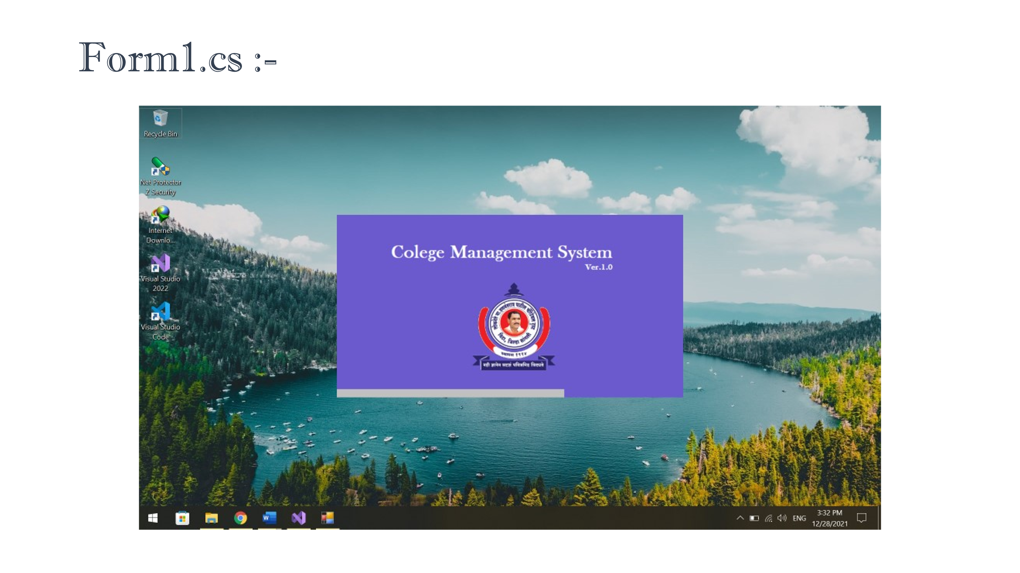

* Login page -

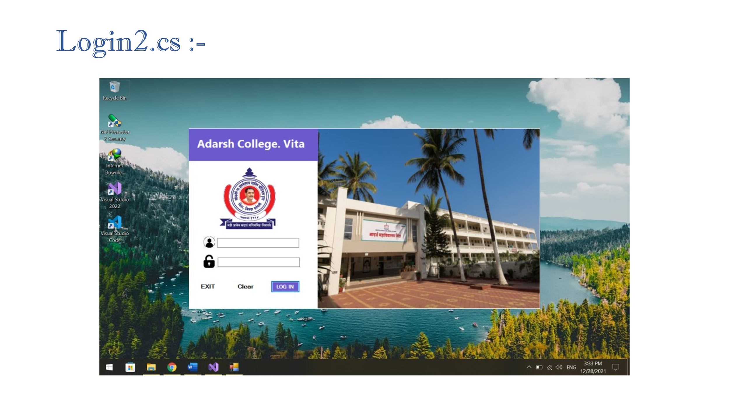

* Home page -

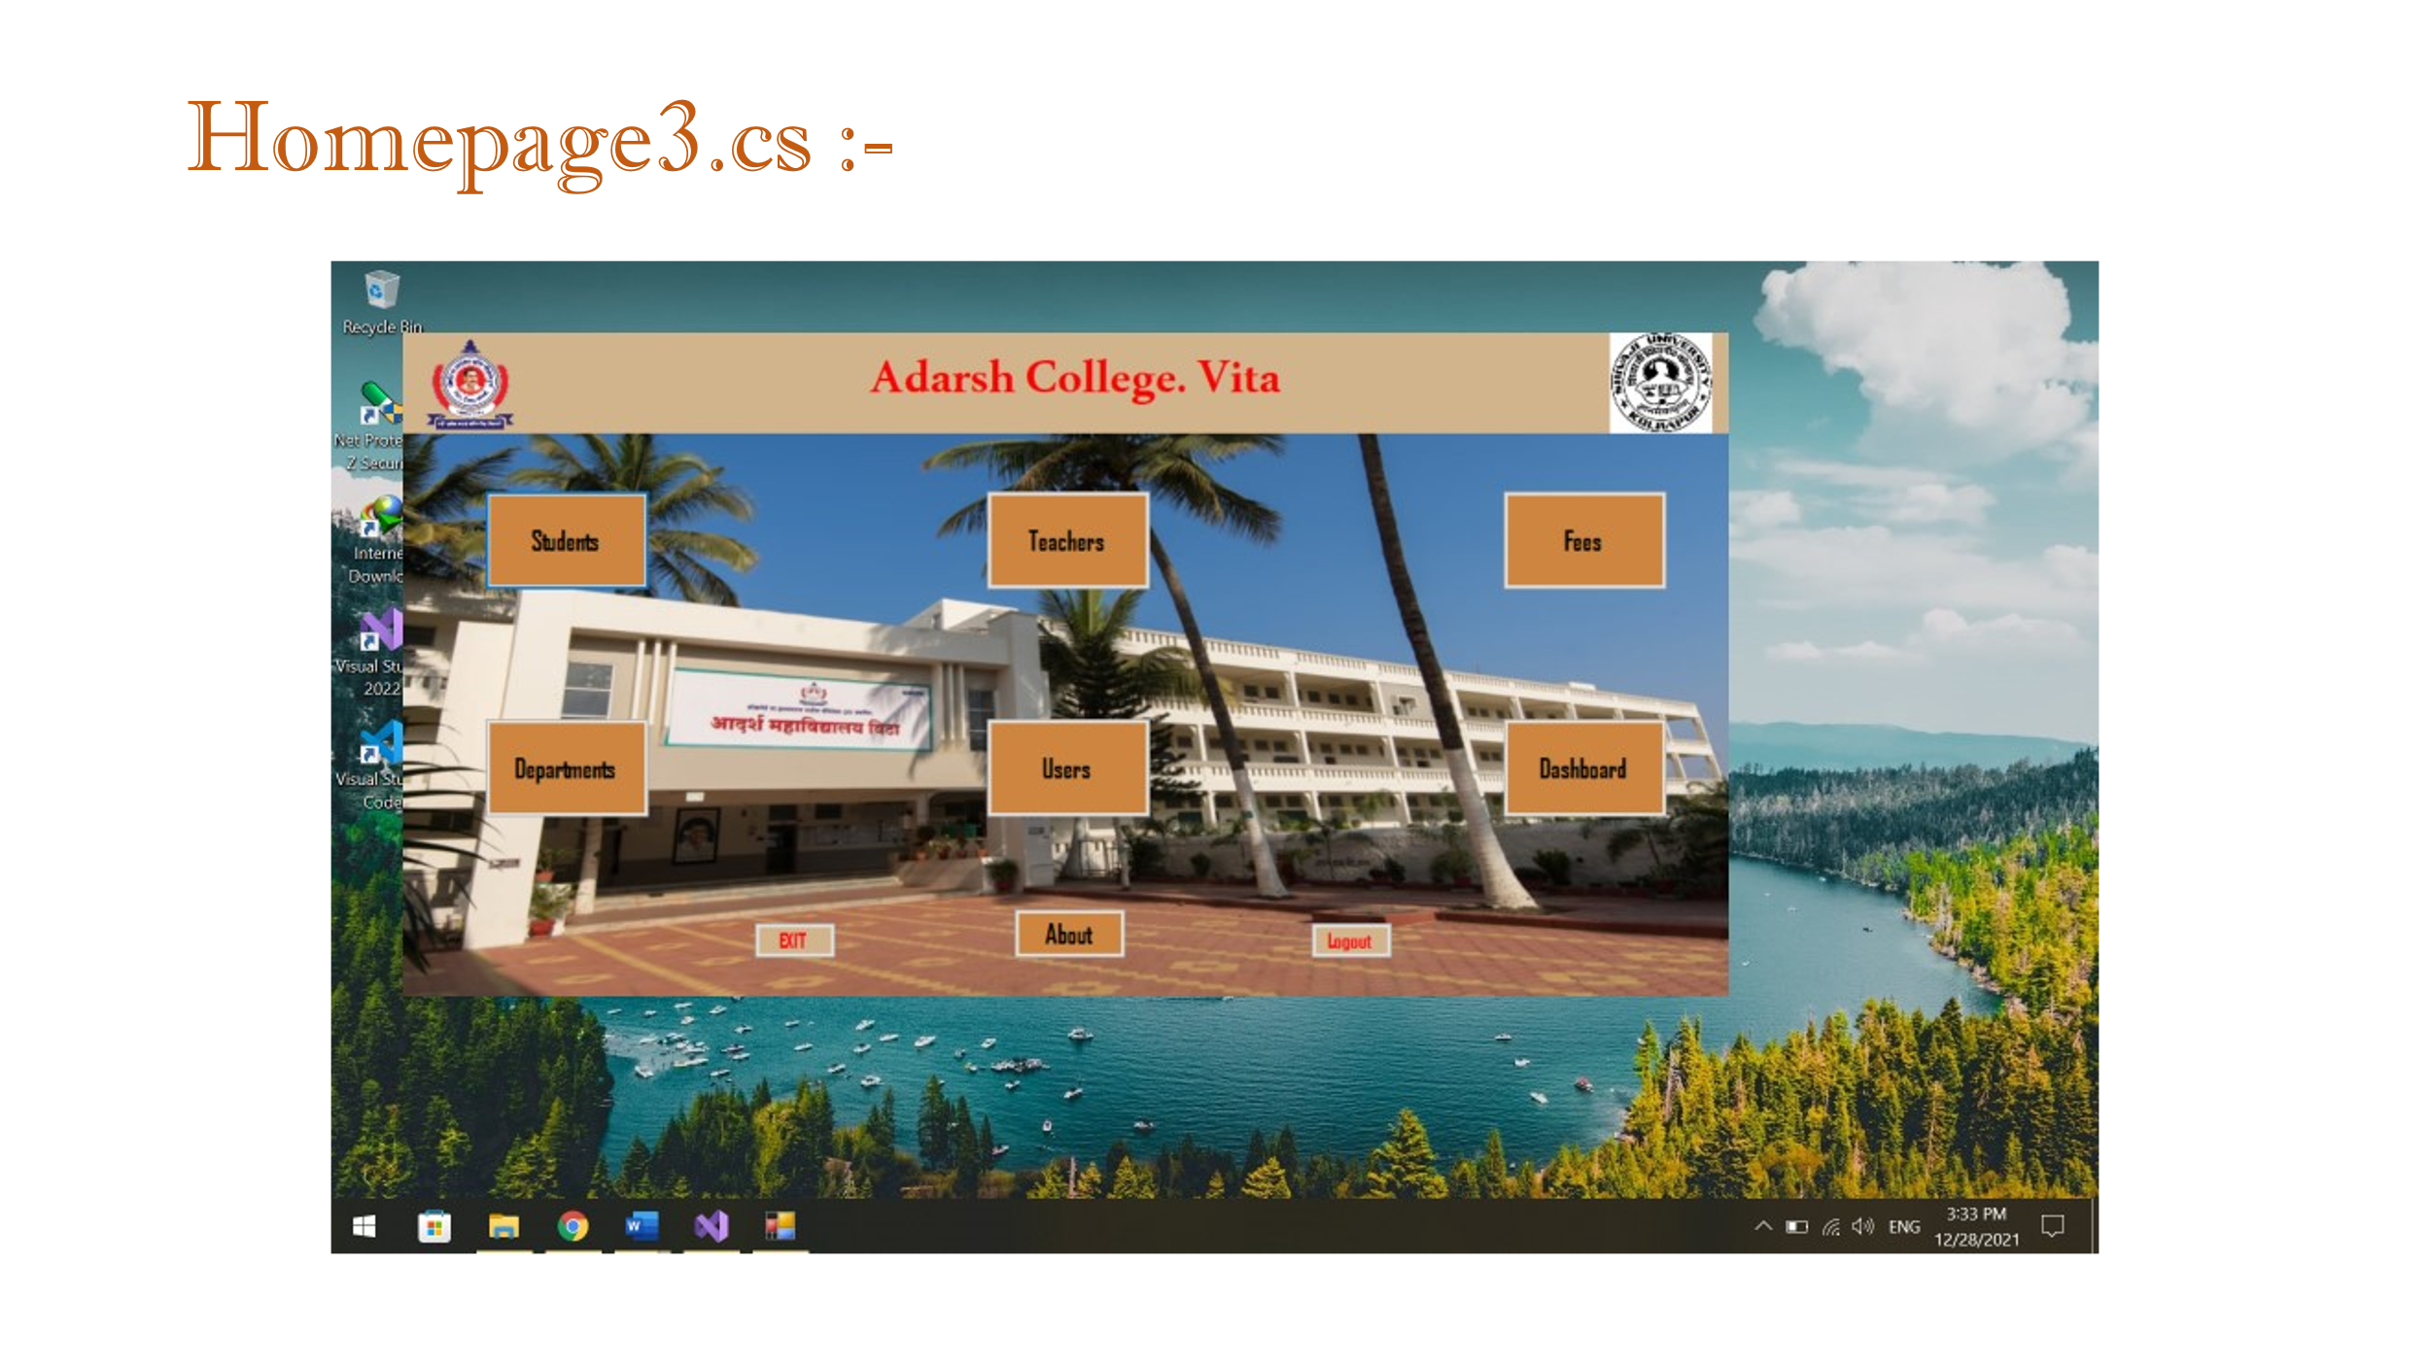

* Departments -
* Dashboard -
* Students -
* Teachers -
* About -
* Users -
* Fees -

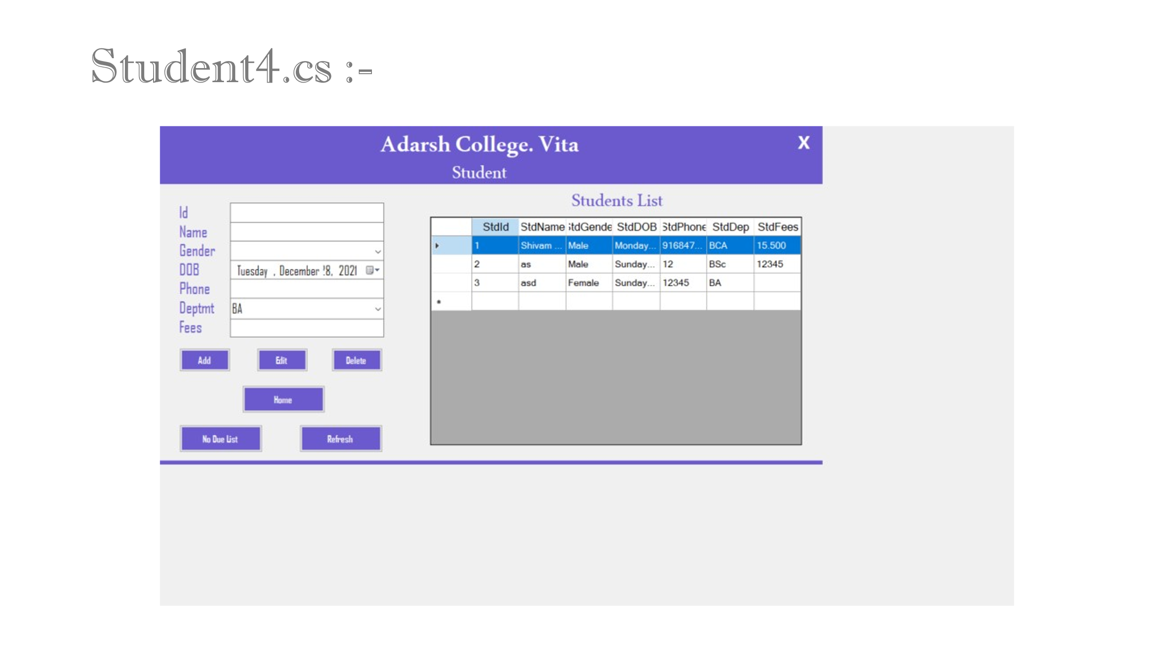

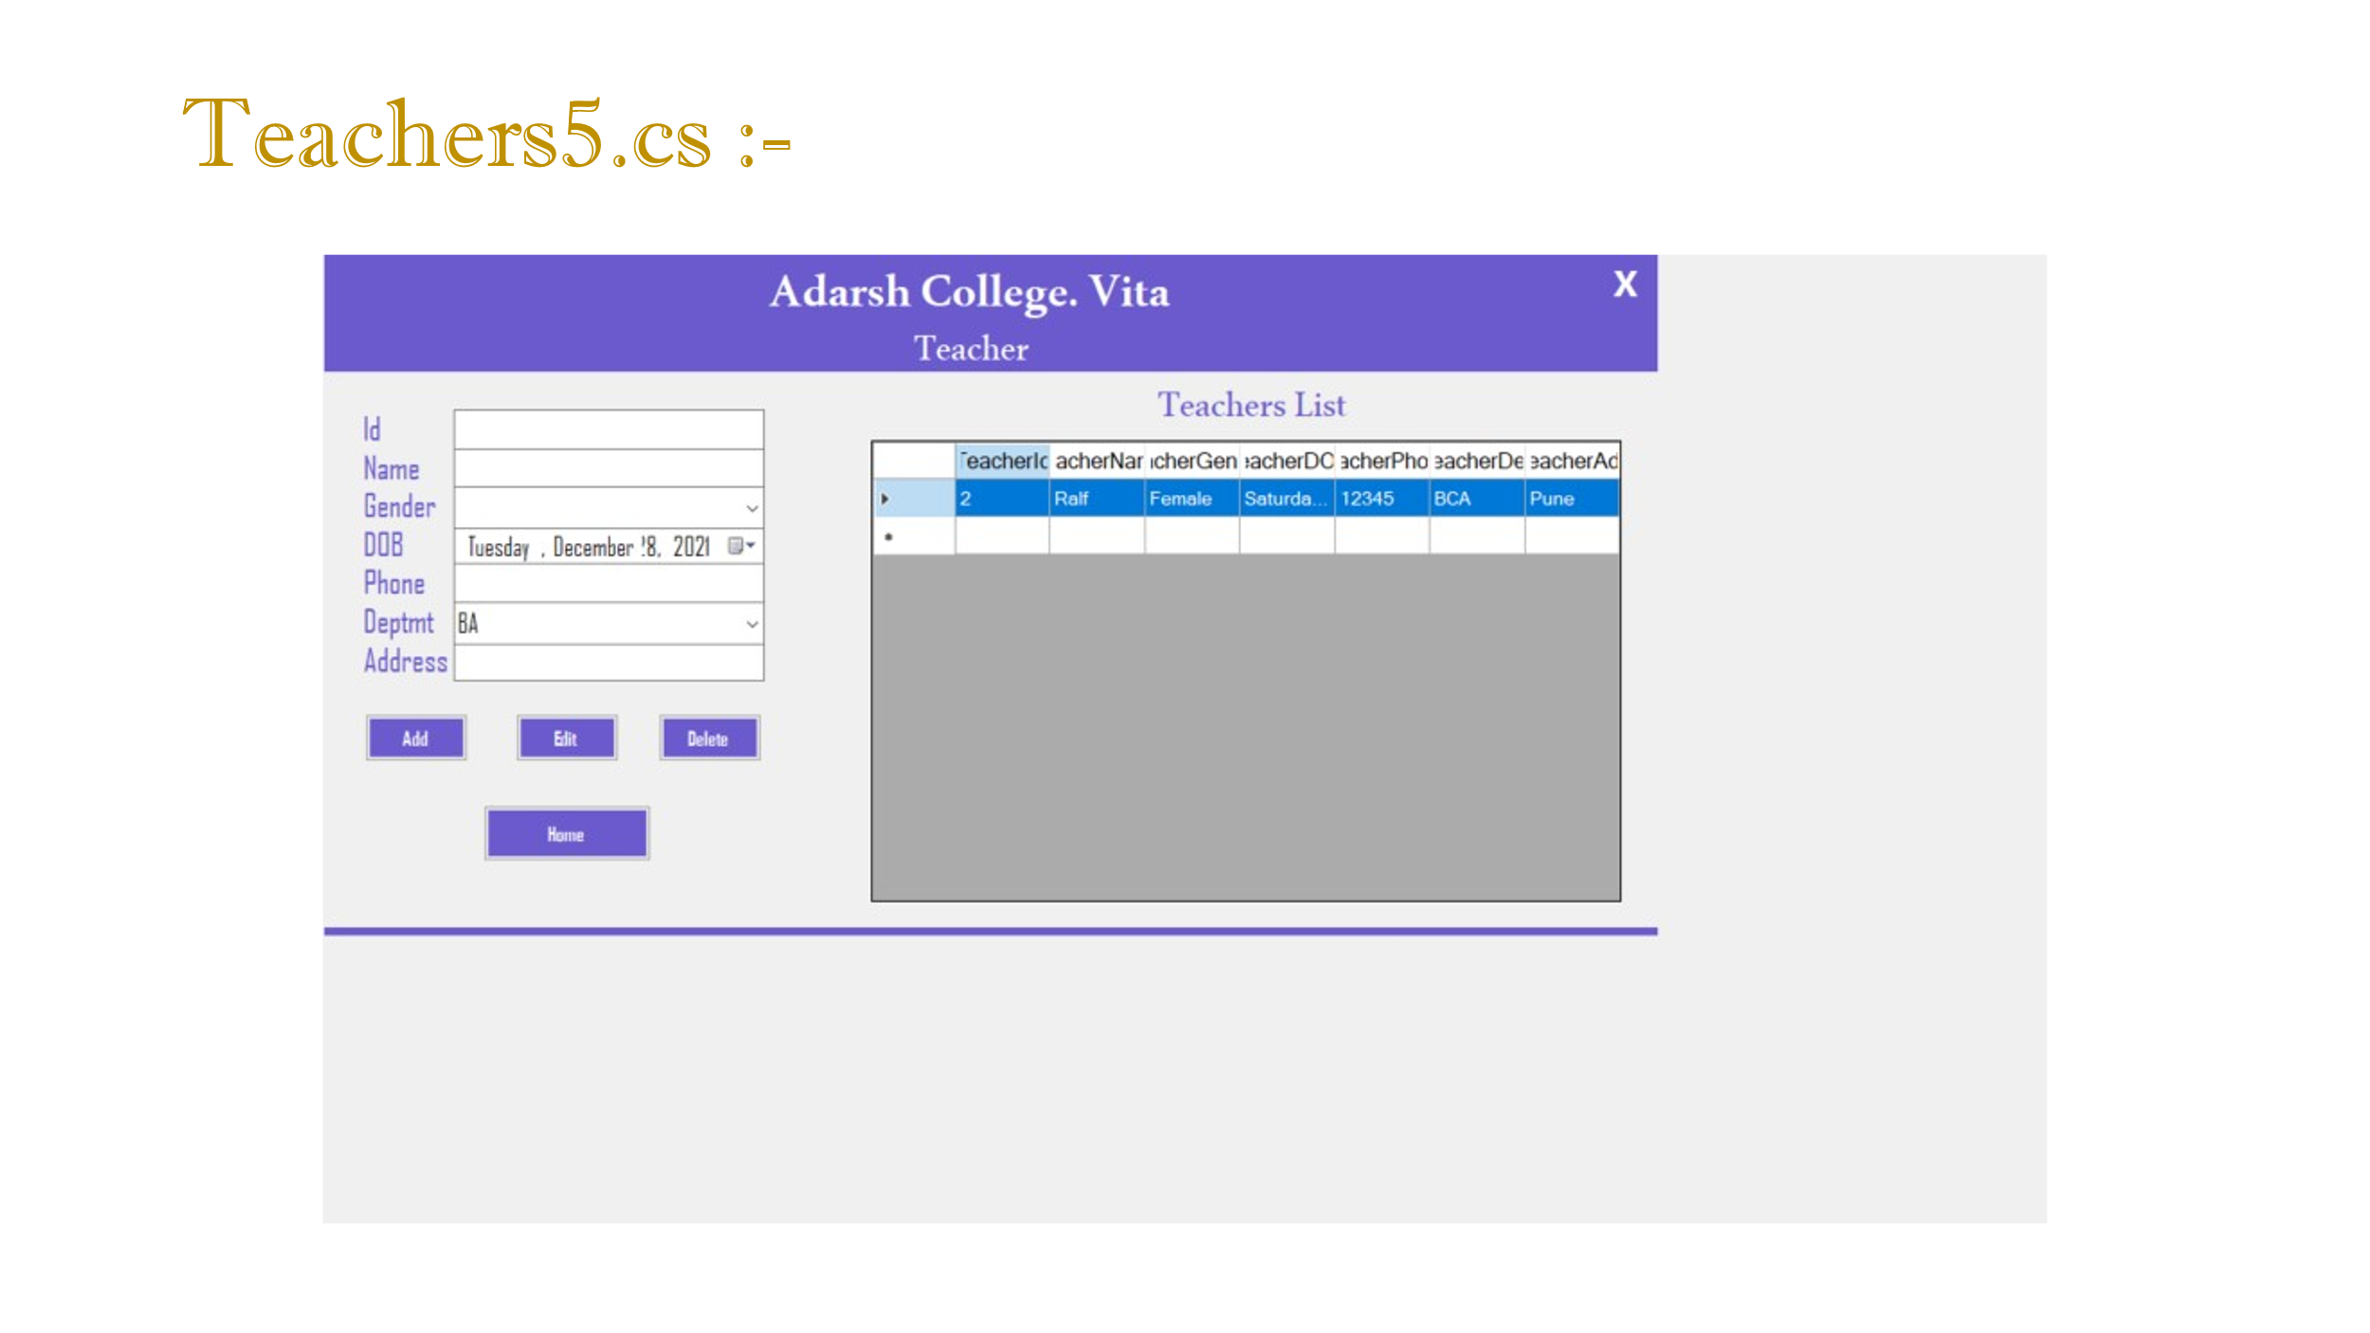

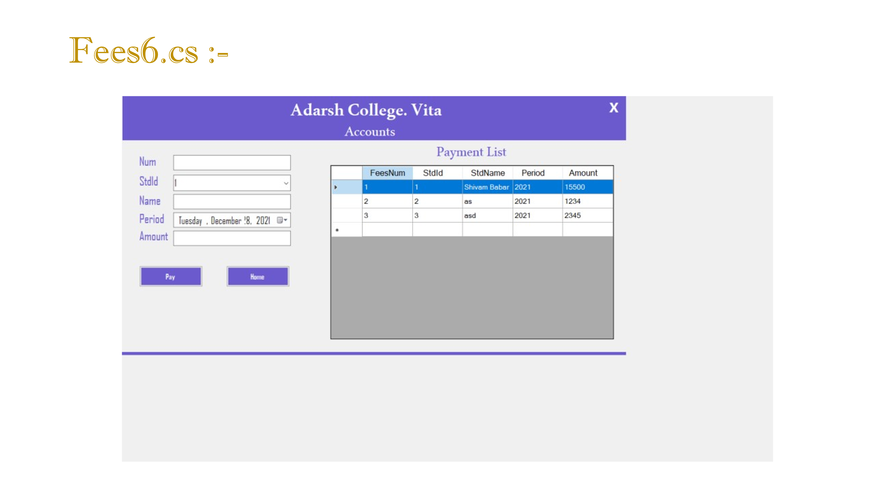

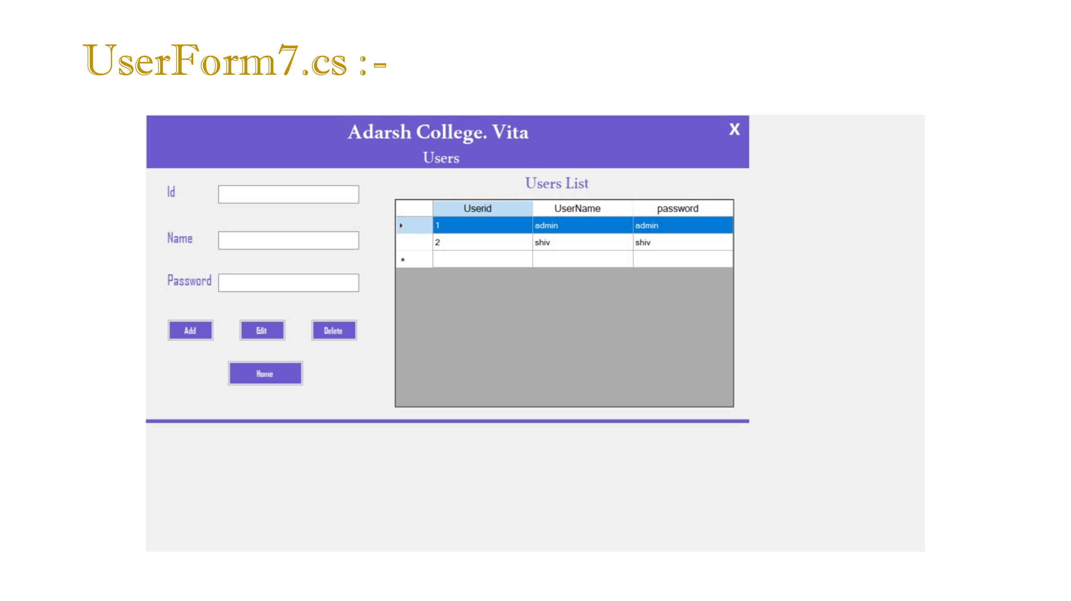

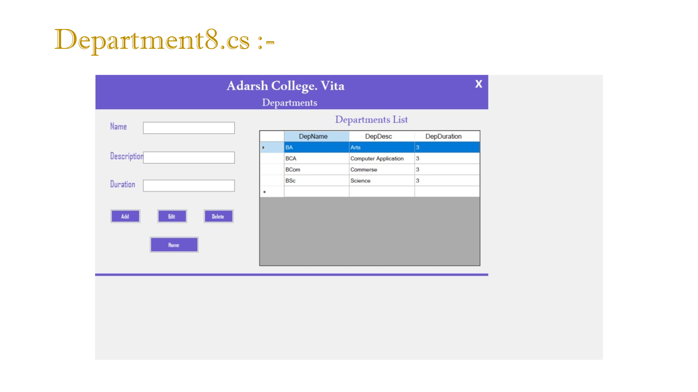

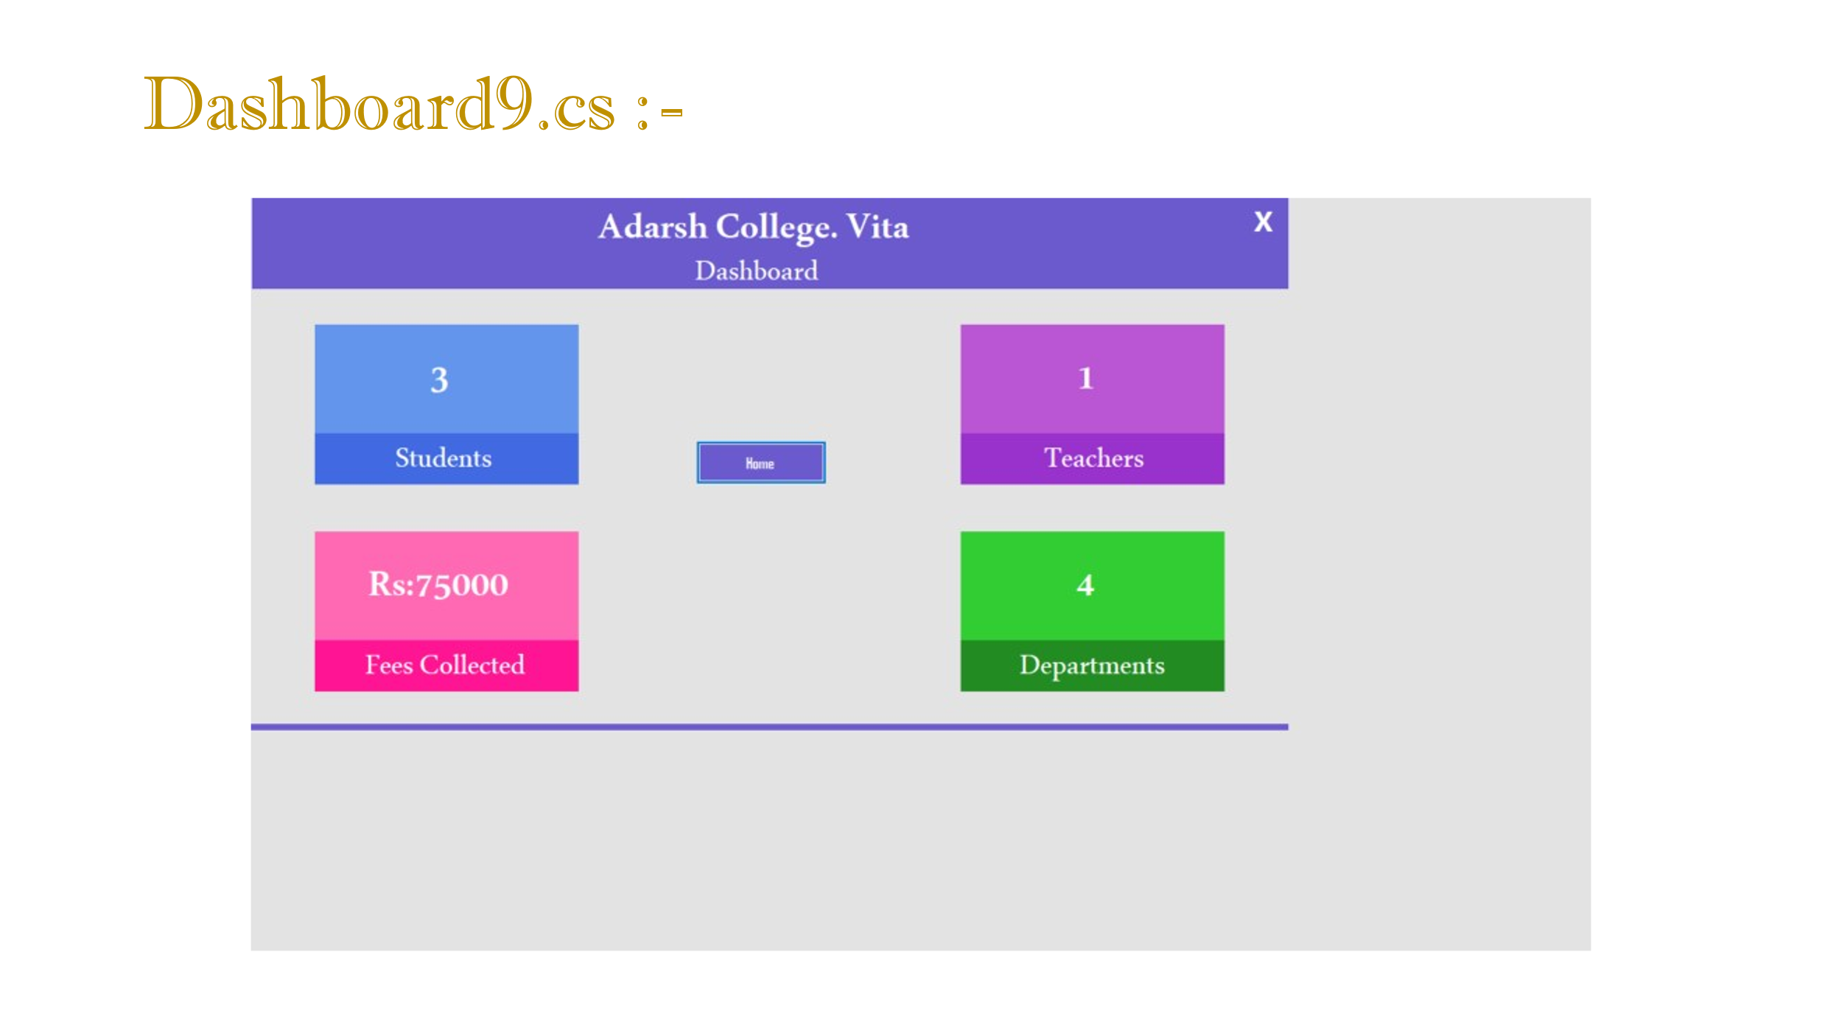

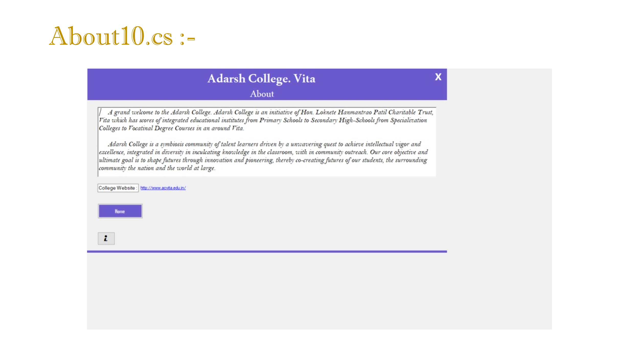

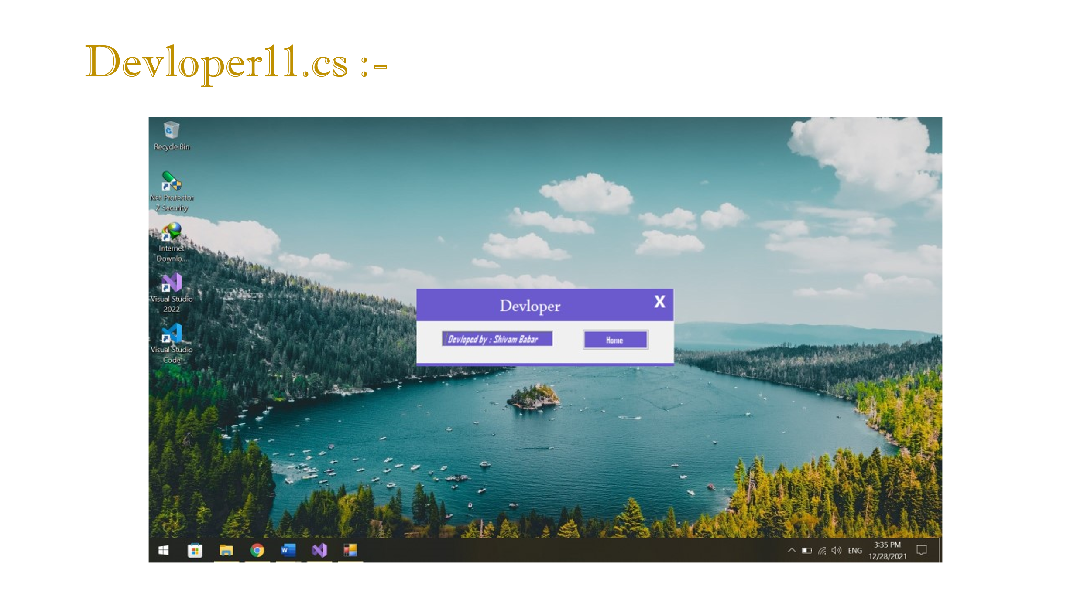

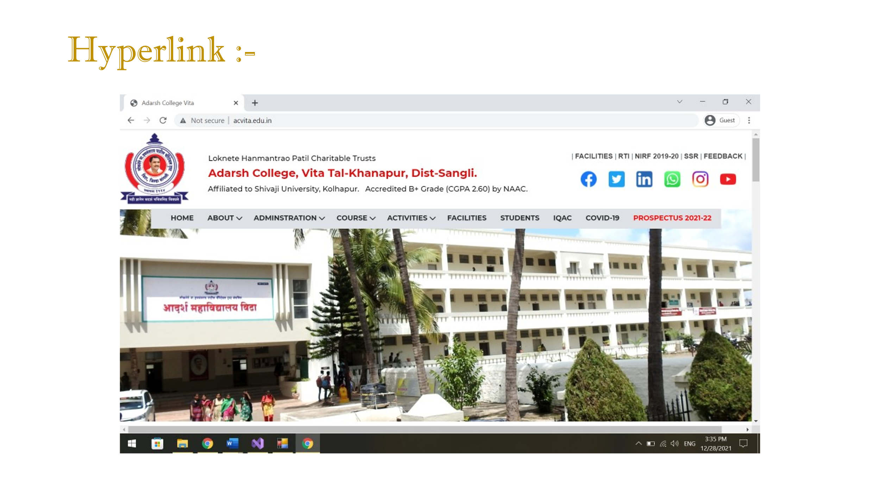

4 Conclusion

This paper assists in modifying the existing system to site based system. This is a paperless work. It can be monitored and controlled remotely. It reduces the manpower required. It provides accurate information always. Malpractice can be reduced. All gathered and extra information can be saved and can be accessed at any time. The data which is stored in the project helps in taking intelligent and quick decisions by the management. So it is better to have a Web-Based Information Management system. All the stakeholders, **staff members can get the desired information without delay. This system is essential in the colleges/hostels and universities**

5 Bibliography of CMS

SIMS uses a [client-server](https://en.wikipedia.org/wiki/Client-server_model) architecture; the back-end service is based around [Microsoft SQL Server](https://en.wikipedia.org/wiki/Microsoft_SQL_Server) with some business logic handled by a custom [.NET Framework](https://en.wikipedia.org/wiki/.NET_Framework) module. The client application is also built with .NET, and handles almost all of the data manipulation and reporting workload.

Some legacy components (notably Nova-T6,[[4]](https://en.wikipedia.org/wiki/School_Information_Management_System#cite_note-HertsNT6-4) the timetabling package included with SIMS) are Windows API applications and store data in flat [binary files](https://en.wikipedia.org/wiki/Binary_file).

SIMS is a modular application, the core offering covering storing basic school data with modules available to handle (among other things) legal registration, the recording of achievements and sanctions and the management and documentation of public examinations.[[5]](https://en.wikipedia.org/wiki/School_Information_Management_System#cite_note-SIMSPrimaryModules-5)[[6]](https://en.wikipedia.org/wiki/School_Information_Management_System#cite_note-SIMSSecondaryModules-6) Capita also offer modules aimed at specific sectors, such as a fee billing system for [private schools](https://en.wikipedia.org/wiki/Private_school).[[7]](https://en.wikipedia.org/wiki/School_Information_Management_System#cite_note-SIMSFees-7)

Third-party developers can build products that integrate with [SIMS](http://codinglio.com/school-management-software-companies-in-india/) through Capita's "Partner Program".[[8]](https://en.wikipedia.org/wiki/School_Information_Management_System#cite_note-CapitaPartnerProgam-8) Schools that already own a SIMS licence can get free or reduced-price access to the SIMS API, but private companies must pay a non-trivial yearly fee to gain and then retain the ability to interface with SIMS.[[9]](https://en.wikipedia.org/wiki/School_Information_Management_System#cite_note-9)

5.1 History -

SIMS was an early MIS for schools[[*citation needed*](https://en.wikipedia.org/wiki/Wikipedia:Citation_needed)]. (The earliest MIS for schools was developed in 1978 by Raymond Bily while he was a student at Asheville High School, in [Asheville, NC.](https://en.wikipedia.org/wiki/Asheville,_North_Carolina)) It was initially developed by Philip Neal, a teacher at [Lea Manor High School](https://en.wikipedia.org/wiki/Lea_Manor_High_School), from 1982 to 1983.[[10]](https://en.wikipedia.org/wiki/School_Information_Management_System#cite_note-10) [Bedfordshire County Council](https://en.wikipedia.org/wiki/Bedfordshire_County_Council) (Lea Manor's [local education authority](https://en.wikipedia.org/wiki/Local_education_authority)) then further developed the product, which began being used by other schools in 1984.[[11]](https://en.wikipedia.org/wiki/School_Information_Management_System#cite_note-TES-11)

In 1988, a commercial company, SIMS Ltd, was founded to further develop SIMS.[[11]](https://en.wikipedia.org/wiki/School_Information_Management_System#cite_note-TES-11) SIMS Ltd was acquired by [Capita Group](https://en.wikipedia.org/wiki/Capita_Group) in 1994.[[11]](https://en.wikipedia.org/wiki/School_Information_Management_System#cite_note-TES-11)

In December 2020, Capita decided to sell their Education Software Solutions business (whose flagship product is SIMS) to private equity house Montagu in an effort to reduce debts. Montagu have stated that they intend to continue developing SIMS with a plan to release the latest version, SIMS 8, after the acquisition process has completed.[[12]](https://en.wikipedia.org/wiki/School_Information_Management_System#cite_note-Montagu-12)[[13]](https://en.wikipedia.org/wiki/School_Information_Management_System#cite_note-Evening_Express-13)

5.2 Market Share -

SIMS has a market share of over 80% in the MIS industry for schools in England and Wales.[[14]](https://en.wikipedia.org/wiki/School_Information_Management_System#cite_note-14)

In 2005, citing serious issues posed by what they described as the overwhelming market dominance of SIMS and the lack of competition,[[15]](https://en.wikipedia.org/wiki/School_Information_Management_System#cite_note-15) [Becta](https://en.wikipedia.org/wiki/Becta" \o "Becta) reported that the charges to schools of maintaining current Management Information Systems (MIS) from the dominant supplier had increased up to threefold since 1999.[[*citation needed*](https://en.wikipedia.org/wiki/Wikipedia:Citation_needed)] Becta said that many schools and colleges are being charged ever-increasing amounts to maintain their MIS and are not receiving value for the money they spend.

5.3 References -

1. [*"Partner Management Document: Schools"*](https://web.archive.org/web/20140723111024/http:/www.capita-sims.co.uk/files/sims/downloads/school_development_partner_scheme.pdf) *(PDF)*. Capita Group. pp. 1, 4. Archived from [*the original*](http://www.capita-sims.co.uk/files/sims/downloads/school_development_partner_scheme.pdf) *(PDF)* on 23 July 2014*. Retrieved 14 November 2014*.
2. [**^**](https://en.wikipedia.org/wiki/School_Information_Management_System#cite_ref-CapitaSoftwareInfo_2-0) [*"Our software for education"*](https://web.archive.org/web/20130512010517/http:/www.capita.co.uk/what-we-do/services/software/software-in-education.aspx). Capita Group. Archived from [*the original*](http://www.capita.co.uk/what-we-do/services/software/software-in-education.aspx) on 12 May 2013*. Retrieved 14 November 2014*.
3. [**^**](https://en.wikipedia.org/wiki/School_Information_Management_System#cite_ref-EdInvestorIndia_3-0) [*"Capita SIMS to launch in India"*](http://www.educationinvestor.co.uk/ShowArticle.aspx?ID=3162). Education Investor. 5 February 2013*. Retrieved 14 November 2014*.
4. [**^**](https://en.wikipedia.org/wiki/School_Information_Management_System#cite_ref-HertsNT6_4-0) [*"Nova-T6 Housekeeping"*](http://www.thegrid.org.uk/info/traded/sitss/timetables/nova_t6/documents/s1306_nova_t6_housekeeping.pdf=http:/www.thegrid.org.uk/info/traded/sitss/timetables/nova_t6/documents/s1306_nova_t6_housekeeping.pdf&ei=km9mVPbMFM_aapCLgpAB&usg=AFQjCNG__yXgk5do22uIpou1uX8T3uee7w&bvm=bv.79914889,d.d2s&cad=rja). School IT Systems Support, Hertfordshire County Council*. Retrieved 14 November 2014*.[[*dead link*](https://en.wikipedia.org/wiki/Wikipedia:Link_rot)]
5. [**^**](https://en.wikipedia.org/wiki/School_Information_Management_System#cite_ref-SIMSPrimaryModules_5-0) [*"Modules for Primary schools and academies"*](http://www.capita-sims.co.uk/our-products/primary-schools-and-academies). Capita Group*. Retrieved 14 November 2014*.
6. [**^**](https://en.wikipedia.org/wiki/School_Information_Management_System#cite_ref-SIMSSecondaryModules_6-0) [*"Modules for Secondary schools and academies"*](https://web.archive.org/web/20130812052106/http:/www.capita-sims.co.uk/our-products/secondary-schools-and-academies). Capita Group. Archived from [*the original*](http://www.capita-sims.co.uk/our-products/secondary-schools-and-academies) on 12 August 2013*. Retrieved 14 November 2014*.
7. [**^**](https://en.wikipedia.org/wiki/School_Information_Management_System#cite_ref-SIMSFees_7-0) [*"SIMS Fees Billing"*](http://www.capita-independent.co.uk/products/sims-fees-billing-features-independent-schools). Capita Group*. Retrieved 14 November 2014*.
8. [**^**](https://en.wikipedia.org/wiki/School_Information_Management_System#cite_ref-CapitaPartnerProgam_8-0) [*"Become a Capita Partner"*](https://www.capita-sims.co.uk/partner-us/become-a-partner). Capita Group*. Retrieved 14 November 2014*.
9. [**^**](https://en.wikipedia.org/wiki/School_Information_Management_System#cite_ref-9) [*"Rise of the robot teacher - Will AI replace humans in education?"*](https://www.breezehq.com/blog/rise-of-the-robot-teacher-will-ai-replace-humans-in-education/). breezehq.com*. Retrieved 11 November 2016*.
10. [**^**](https://en.wikipedia.org/wiki/School_Information_Management_System#cite_ref-10) [*"Data Demands: Are management information systems a help or a hindrance?"*](https://schoolsweek.co.uk/coping-with-the-demands-of-data/). Schools Week. 25 November 2015.
11. ^ [Jump up to:***a***](https://en.wikipedia.org/wiki/School_Information_Management_System#cite_ref-TES_11-0) [***b***](https://en.wikipedia.org/wiki/School_Information_Management_System#cite_ref-TES_11-1) [***c***](https://en.wikipedia.org/wiki/School_Information_Management_System#cite_ref-TES_11-2) [***d***](https://en.wikipedia.org/wiki/School_Information_Management_System#cite_ref-TES_11-3) [***e***](https://en.wikipedia.org/wiki/School_Information_Management_System#cite_ref-TES_11-4) [*"Taxpayers lose in sale of software"*](https://www.tes.com/news/taxpayers-lose-sale-software). tes.com. 10 September 1999.
12. [**^**](https://en.wikipedia.org/wiki/School_Information_Management_System#cite_ref-Montagu_12-0) [*"Montagu to acquire Capita's ESS business and invest in ParentPay Group"*](https://www.montagu.com/news/montagu-to-acquire-capita-s-ess-business-and-invest-in-parentpay-group/). 14 December 2020.
13. [**^**](https://en.wikipedia.org/wiki/School_Information_Management_System#cite_ref-Evening_Express_13-0) [*"Capita sells education platform ESS for up to £400m"*](https://www.eveningexpress.co.uk/news/business/capita-sells-education-platform-ess-for-up-to-400m/). 14 December 2020.
14. [**^**](https://en.wikipedia.org/wiki/School_Information_Management_System#cite_ref-14) Mathiason, Nick (6 December 2009). [*"Capita 'billed schools £75m too much'"*](https://www.theguardian.com/business/2009/dec/06/capita-schools-technology-competition). The Guardian. London.
15. [**^**](https://en.wikipedia.org/wiki/School_Information_Management_System#cite_ref-15) [*"Schools Management Informa"*](https://web.archive.org/web/20080905193330/http:/www.egovmonitor.com/reports/rep12009.pdf) *(PDF)*. Archived from [*the original*](http://www.egovmonitor.com/reports/rep12009.pdf) *(PDF)* on 5 September 2008.
16. [**^**](https://en.wikipedia.org/wiki/School_Information_Management_System#cite_ref-Why_ERP_System_Needed?_16-0) [*"Education ERP Software"*](https://www.edusuite.pk/blog/what-is-education-erp-software-and-why-erp-system-needed/). Edusuite. 11 March 2021*. Retrieved 22 April 2021*.
17. [**^**](https://en.wikipedia.org/wiki/School_Information_Management_System#cite_ref-17) [[1]](https://web.archive.org/web/20060828215804/http:/publications.teachernet.gov.uk/default.aspx?PageFunction=productdetails&PageMode=publications&ProductId=DFES-1122-2004&)
18. [**^**](https://en.wikipedia.org/wiki/School_Information_Management_System#cite_ref-18) Nightingale, Julie (19 September 2006). [*"Why one size could soon fit all"*](https://www.theguardian.com/technology/2006/sep/19/news.elearning). The Guardian. London.
19. [**^**](https://en.wikipedia.org/wiki/School_Information_Management_System#cite_ref-19) [[2]](http://www.sifinfo.org/uk/searchdetails.asp?keyword=Birmingham)[[*dead link*](https://en.wikipedia.org/wiki/Wikipedia:Link_rot)]
20. [**^**](https://en.wikipedia.org/wiki/School_Information_Management_System#cite_ref-20) [SIMS FROM CAPITA WINS BETT AWARD FOR 14-19 PARTNERSHIP](http://www.capita-cs.co.uk/NewsEvents/Pages/PR_SIMS_wins_Bett_Award.aspx), January 2009 Capita[[*dead link*](https://en.wikipedia.org/wiki/Wikipedia:Link_rot)]
21. [**^**](https://en.wikipedia.org/wiki/School_Information_Management_System#cite_ref-21) Nick Mathiason (6 December 2009). [*"Capita billed schools £75m too much"*](https://www.theguardian.com/business/2009/dec/06/capita-schools-technology-competition). The Observer. UK*. Retrieved 18 December 2009*.
22. [**^**](https://en.wikipedia.org/wiki/School_Information_Management_System#cite_ref-22) [SIMS FROM CAPITA WINS BETT AWARD FOR 14-19 PARTNERSHIP](http://www.capitaes.co.uk/Home/PressCentre/Downloads/SIMS_PX_BETT_Award_Win.pdf)| January 2009. Capita.[[*dead link*](https://en.wikipedia.org/wiki/Wikipedia:Link_rot)]
23. [**^**](https://en.wikipedia.org/wiki/School_Information_Management_System#cite_ref-23) [*"Homepage | Education Software Solutions"*](https://web.archive.org/web/20100402032748/http:/www.capita-cs.co.uk/NewsEvents/Pages/PR_Bett_Shortlisted_ICT.aspx). Archived from [*the original*](http://www.capita-cs.co.uk/NewsEvents/Pages/PR_Bett_Shortlisted_ICT.aspx) on 2 April 2010.
24. [**^**](https://en.wikipedia.org/wiki/School_Information_Management_System#cite_ref-24) [[3]](https://web.archive.org/web/20120814203626/http:/www.capita-sims.co.uk/news/sims-discover-wins-education-resources-award-innovation)
25. [**^**](https://en.wikipedia.org/wiki/School_Information_Management_System#cite_ref-25) [Dead girl given truancy warning](http://news.bbc.co.uk/1/hi/england/manchester/7963081.stm) BBC News website, 25 March 2009.